**PRACTICAL - 1**

**AIM: Design a web page using different text formatting tags. CODE:**

<!DOCTYPE html>

<html lang="en" dir="ltr">

<head>

<meta charset="utf-8">

<title>Practical 1</title>

</head>

<body>

<p><b>The Beauty And The Beast</b></p>

<p>Originating in <strong>France</strong>, this is the story of <mark>Belle</mark>, a beautiful peasant girl

who took the place of her <em>father</em>,when he was taken <u>prisoner by a fierce beast.</u>

<br>While things were uncomfortable and frightening for Belle at first, <i>she soon grew fond of the beast,</i>

as he had done nothing but treat her with <big>kindness</big>.<br> When Belle found out her father was sick,

she begged the beast to let her go to him and promised to return, but she was held up by the evil <ins>Gaston</ins>,

<br>a famous hunter from the village who wanted to marry Belle.<small>When the village found out about the</small> beast,

they vowed <sup>[1]</sup> to kill him and stormed his castle.<br>Though he nearly died, he was saved and turned into a

handsome prince <mark>because of Belle’s love for him</mark>.It turns out that he had been a prince who,

along with his entire household,<br>was cursed by a <big>witch</big> because he did not treat her with kindness.

Belle and the Prince marry, <del>and live a happy and peaceful life together</del> peacefully lived together.</p>

<p>1. vowed- took an oath; pledged</p>

<p>the molecular formula of glucose is =

<big>C<sub>6</sub>H<sub>12</sub>O<sub>6</sub></big> </p>

<p>the square of 4 is: 4<sup>2</sup>=16</p>

</body></html>

**OUTPUT:**

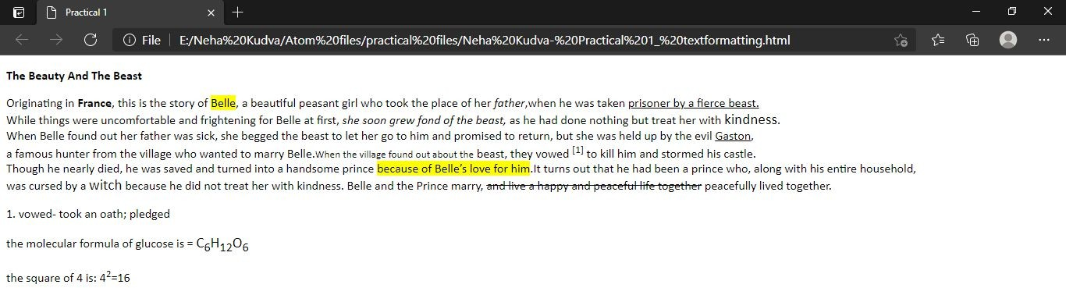

**PRACTICAL - 2**

**AIM: Design a web page with different types of Marquee. CODE:**

<!DOCTYPE html>

<html lang="en" dir="ltr">

<head>

<meta charset="utf-8">

<title>Marquee</title>

</head>

<body topmargin="100" bgcolor="black">

<marquee bgcolor="yellow" direction="left" vspace="20" height="30px">

<strong>Hello World, I am left direction marquee!</strong>

</marquee>

<marquee bgcolor="yellow" direction="right" vspace="20" height="30px">

<strong>Hurray! I move from Right Direction</strong>

</marquee>

<marquee bgcolor="yellow" direction="up" height="150px" vspace="20">

<center><b>I am 150px in height and I move in up direction.</b></center>

</marquee>

<marquee bgcolor="yellow" direction="down" height="150px" vspace="20">

<center><b>I am 150px in height and I move in down direction.</b></center>

</marquee>

<marquee bgcolor="yellow" direction="left" height="30px" vspace="20" scrollamount="3">

<b>Marquee with slow speed</b>

</marquee>

<marquee bgcolor="yellow" direction="left" height="30px" vspace="20" scrollamount="10">

<b>Marquee with moderate speed</b>

</marquee>

<marquee bgcolor="yellow" direction="left" height="30px" vspace="20" scrollamount="35">

<b>Marquee with fast speed</b>

</marquee>

<marquee bgcolor="yellow" direction="left" height="30px" vspace="20" scrolldelay="2000">

<b>Caution: This marquee is delayed by 2 seconds.</b>

</marquee>

<marquee bgcolor="yellow" direction="left" height="30px" vspace="20" loop="5" scrollamount="15">

<b>This marquee in on loop of 5</b>

</marquee>

</body>

</html>

**OUTPUT:**

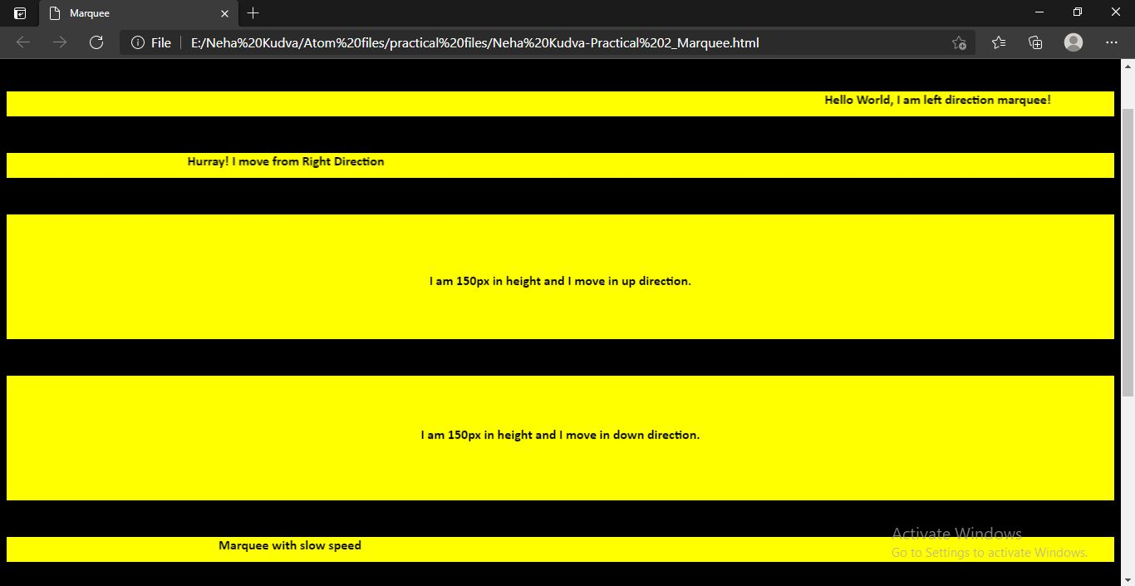

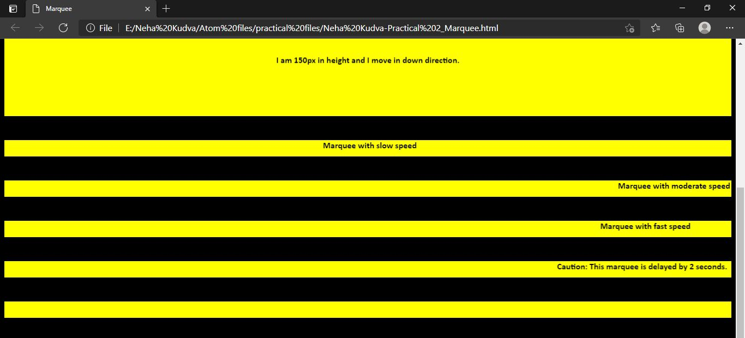

**PRACTICAL - 3**

**AIM: Design a web page with links to different pages and allow navigation between pages.**

**CODE:**

1. **Home page (index.html)**

<!DOCTYPE html>

<html>

<head>

<meta charset="utf-8">

<title>Home Page</title>

</head>

<body >

<a id="top"></a>

<a href="#bottom">go to end of page</a><br>

<center><img src="./Heritage-Banner-1920X760.jpg" alt="img" width="1300px" height="300px"></center>

<img src="./logo.png" alt="logo" height="120px" width="100px" align="left" style="margin-left:150px;"><br>

&nbsp;&nbsp;<br>

<hr>

<h3 align="center">&nbsp;&nbsp;<a href="./aboutus.html">ABOUT US</a>

<a href="./menu.html">MENU</a>&nbsp;&nbsp;|&nbsp;&nbsp;

<a href="https://[www.cafecoffeeday.com/](http://www.cafecoffeeday.com/)">CONTACT US</a>&nbsp;&nbsp;</h3>

<hr><br>

<img src="./1920x760 (1).jpg" alt="img" width="1250px" height="350px" style="margin-left:45px;"><br><br>

<p>Café Coffee Day Global Limited Company is a Chikkamagaluru-based business which grows coffee in its own estates of 20,000 acres.

It is the largest producer of arabica beans in Asia, exporting to various countries including U.S., Europe, and Japan.</p>

<ul>

<li>Coffee Day Fresh 'n' Ground, which owns 375 coffee bean and powder retail outlets</li>

<li>Coffee Day Square, a high-level coffee bar in Bangalore, Kolkata, Chennai, Mumbai and New Delhi</li></ul>

<a href="#top" style="margin-left:45px;">go to start of page</a>

<a id="bottom"></a><br>

<br><br><br><br>

</body></html>

1. **About us (aboutus.html)**

<!DOCTYPE html>

<html lang="en" dir="ltr">

<head>

<meta charset="utf-8">

<title>About Us</title>

</head>

<body>

<center><img src="./Safety-CCD-Web Banner-Desktop.png" alt="img" width="1200px" height="400px"></center>

<br>

<a href="./index.html"><pre style="text-align:right; margin-right:50px">back to homepage</pre></a>

<center>

<h1><font face="Gabriola"><u>About Us</u></font></h1>

<p>Café Coffee Day, a part of Coffee Day Global Limited, is India’s favourite hangout for coffee and conversations.</p>

<p>Popularly known as CCD, we strive to provide the best experience to our guests.</p>

<p>Our coffees are sourced from thousands of small coffee planters, who made us who we are today and we're glad to be a part of their lives.</p>

<p>We opened our first cafe in 1996 at Brigade Road in Bangalore – the youth and the young at heart immediately took to the cafe,</p>

<p>and it continues to be one of the most happening places in the city. CCD to the youth is a “hangout” spot</p>

<p>where they meet people, make conversations, and have a whole lot of fun over steaming cups of great coffee.</p>

<p>It's been an exciting journey since then to becoming the largest organised retail cafe chain in the country.</p>

<p>We’re also present in Austria, Czech Republic and Malaysia, so if your travel takes you there, do stop by our outlets to get a taste from back home!</p><br>

<br><br><br>

</center>

</body>

</html>

1. **Menu Page(menu.html)**

<!DOCTYPE html>

<html lang="en" dir="ltr">

<head>

<meta charset="utf-8">

<title>Menu</title>

</head>

<body>

<center><img src="./R-Website Banner.png" alt="img" width="1300px" height="300px"></center><br>

<a href="./index.html"><pre style="text-align:right; margin-right:50px">back to homepage</pre></a><hr>

<font face="Gabriola" size="10px" style="margin- left:100px;"><u>MENU</u></font></menu><br>

<img src="./download.jpg" alt="img">&nbsp;&nbsp;&nbsp;&nbsp;

<img src="./download (1).jpg" alt="img">&nbsp;&nbsp;&nbsp;&nbsp;

<img src="./images.jpg" alt="img">&nbsp;&nbsp;&nbsp;&nbsp;

<img src="./unnamed.jpg" alt="img">&nbsp;&nbsp;&nbsp;&nbsp;

<img src="./m25-15405399635bd2c63b6edd0.jpg">&nbsp;&nbsp;&nbsp;&nbsp;

<img src="./images (1).jpg" alt="img">

</body>

</html>

**OUTPUT:**

1. **Home Page (index.html)**

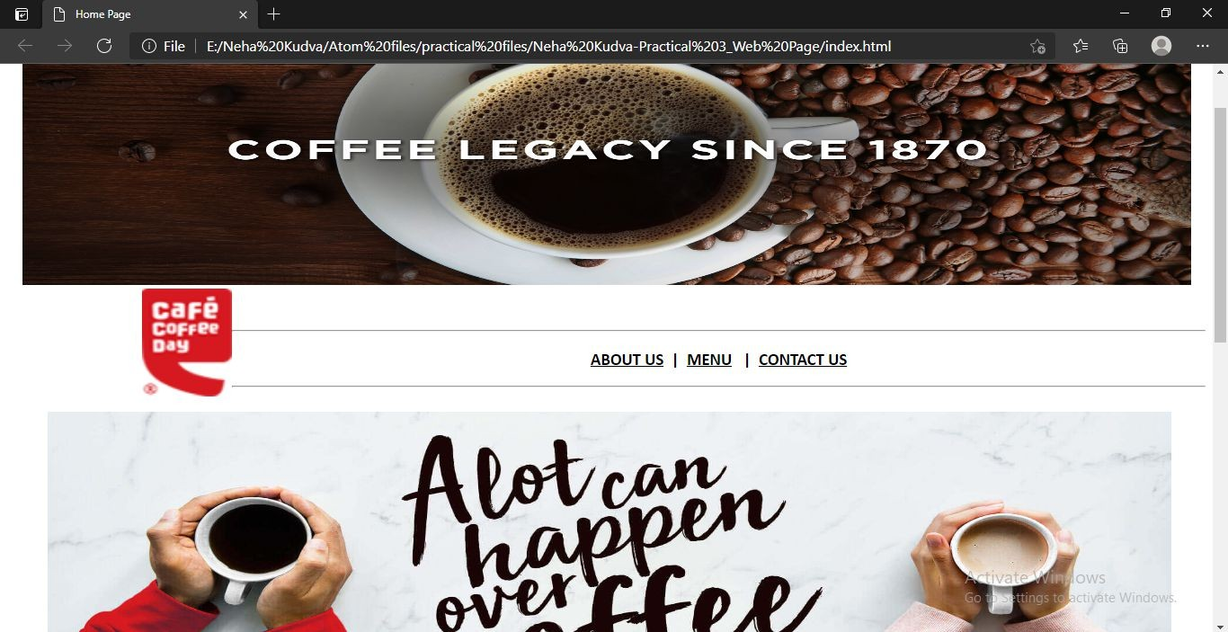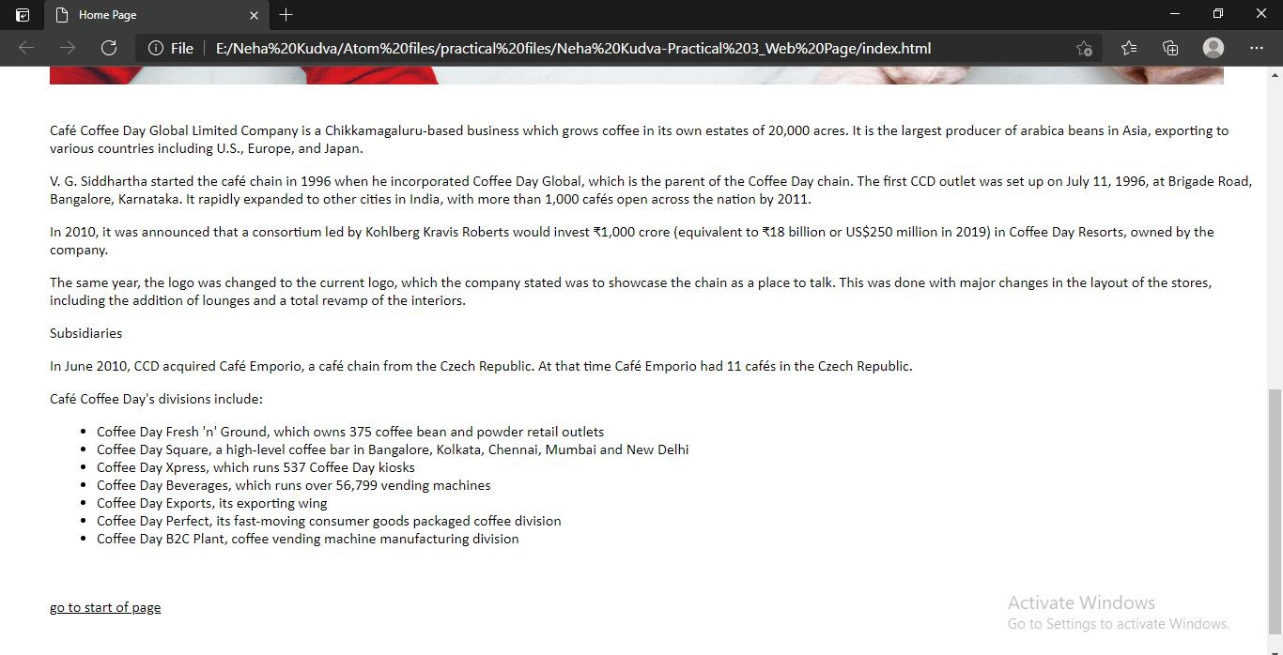

1. **About Page (aboutus.html)**

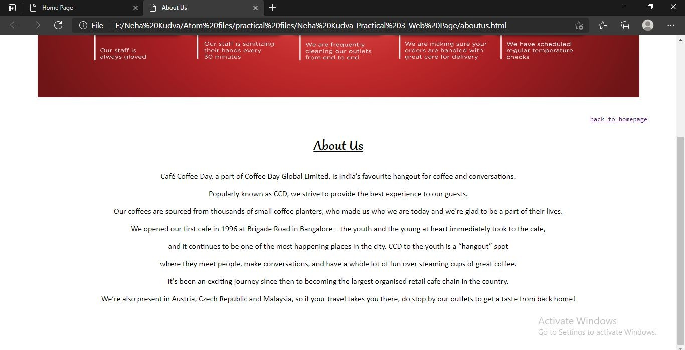

1. **Menu Page (menu.html)**

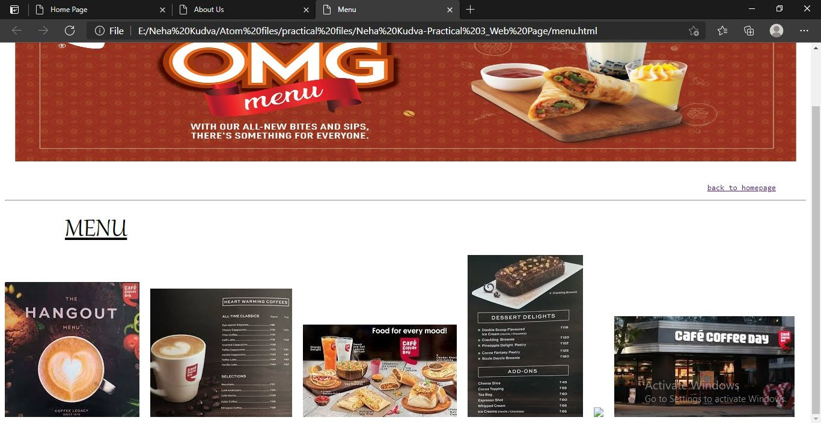

**PRACTICAL - 4**

**AIM: Design a web page with Image and Image maps. CODE:**

<!DOCTYPE html>

<html lang="en" dir="ltr">

<head>

<meta charset="utf-8">

<title>Practical 4</title>

</head>

<body>

<img src="./download.jpg" alt="space" usemap="#space" height="750" width="900">

<map name="space">

<area shape="rect" coords="490,269,692,383" href="./rectangle.html" >

<area shape="poly" coords="200,353,218,374,213,398,183,395,175,374"

href="./pentagon.html" >

<area shape="circle" coords="120,120,100" href="./circle.html" >

<area shape="poly" coords="334,341,275,414,408,444" href="./triangle.html">

</map>

</body>

</html>

**OUTPUT:**

* 1. **circle.html**

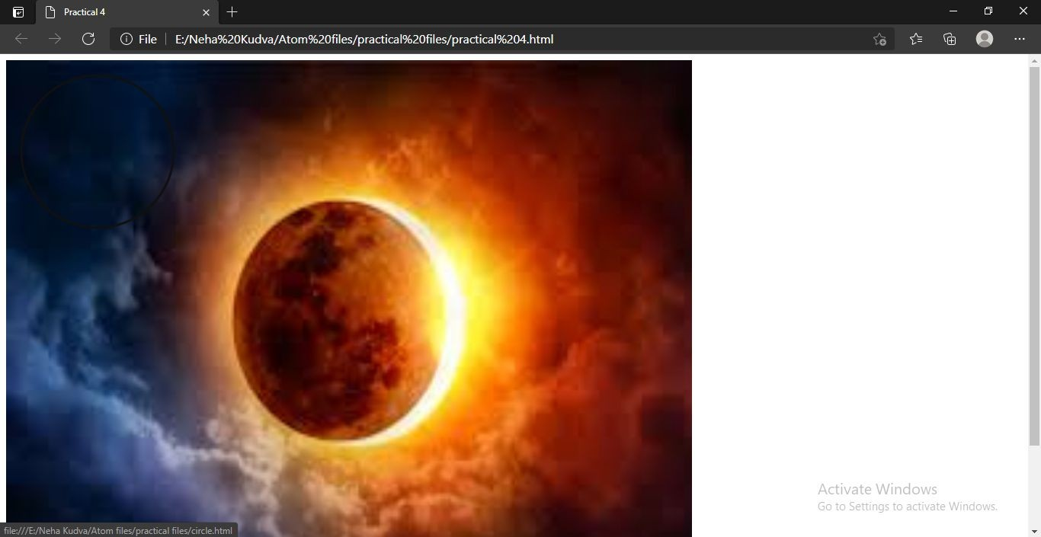

* 1. **rectangle.html**

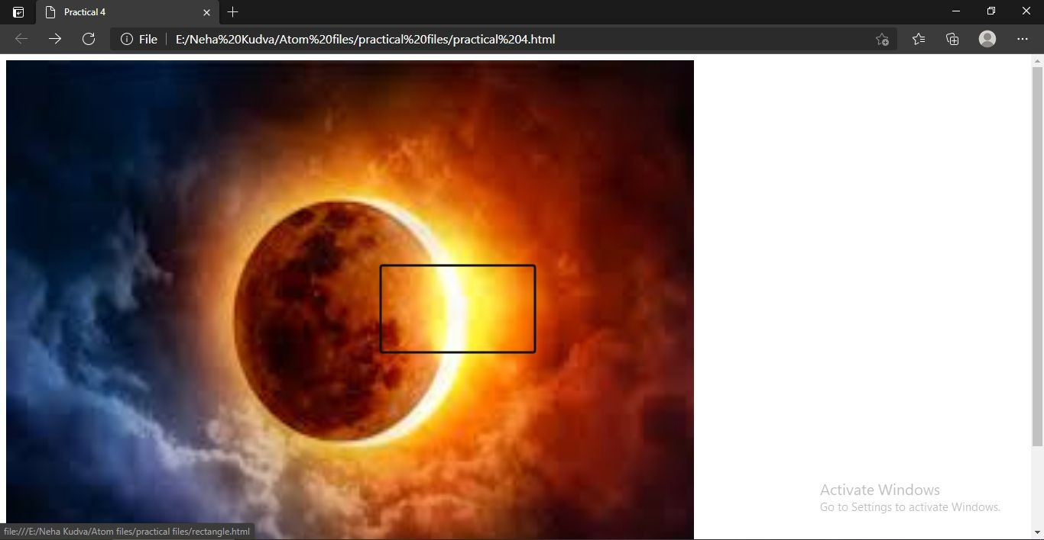

* 1. **triangle.html**

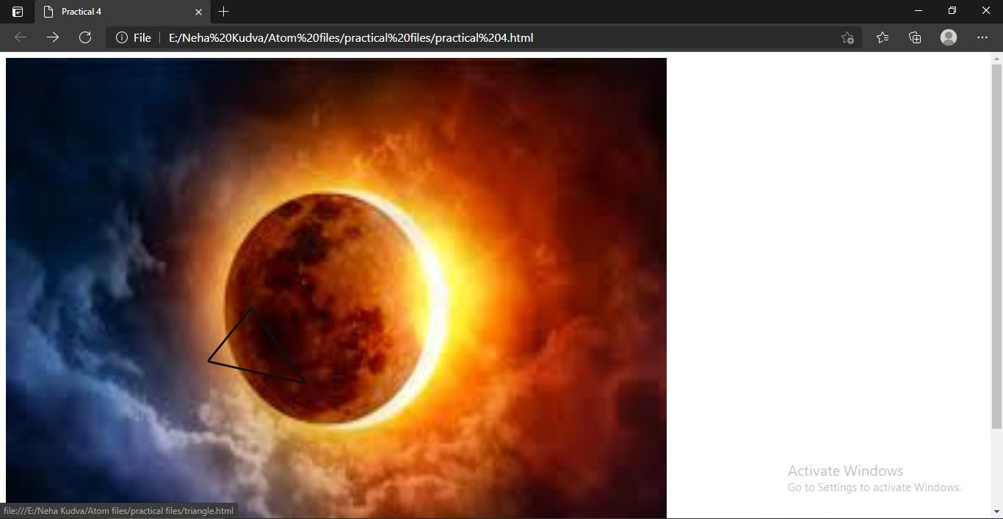

* 1. **pentagon.html**

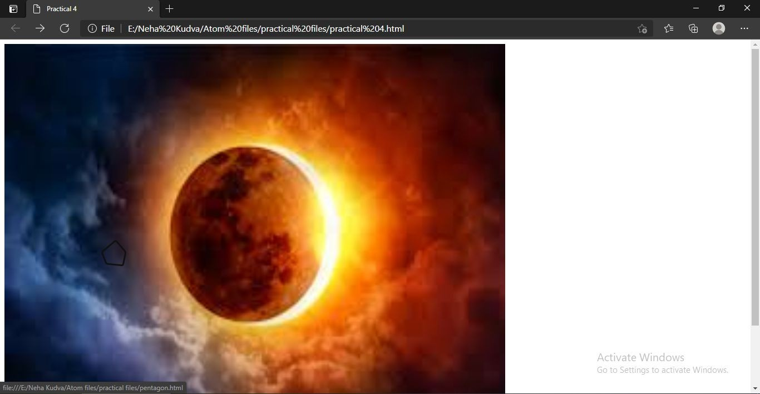

**PRACTICAL - 5**

**AIM: Create a student table with the following fields. Student Id, Name, DOB, Course, Address, E-mail id and apply Embedded cascading style sheet CSS with the following attributes: Font size, color, style, bold, italic, border color, set the background image & set the center align of table & text.**

**CODE:**

<!DOCTYPE html>

<html lang="en" dir="ltr">

<head>

<meta charset="utf-8">

<title>Students Details</title>

</head>

<body>

<table border="1" align="center" cellpadding="10px">

<caption><h1>Students Details</h1></caption>

<tr>

<td>Student Id</td>

<td>Name</td>

<td>DOB</td>

<td>Course</td>

<td>Address</td>

<td>Email Id</td>

</tr>

<tr>

<td>101</td>

<td>Ajay Kulkarni</td>

<td>25/12/2001</td>

<td>BCA</td>

<td>Malad</td>

<td>[ajai2001@gmail.com](mailto:ajai2001@gmail.com)</td>

</tr>

<tr>

<td>102</td>

<td>Nisha Rane</td>

<td>7/9/2001</td>

<td>BCA</td>

<td>Goregaon</td>

<td>[nrane@gmail.com](mailto:nrane@gmail.com)</td>

</tr>

<tr>

<td>103</td>

<td>Mithila Palkar</td>

<td>3/7/2001</td>

<td>BCA</td>

<td>Dahisar</td>

<td>[mithilap@gmail.com](mailto:mithilap@gmail.com)</td>

</tr>

<tr>

<td>104</td>

<td>Dhruv Dixit</td>

<td>2/8/2001</td>

<td>BCA</td>

<td>Mira Road</td>

<td>[dhruvdixit@gmail.com](mailto:dhruvdixit@gmail.com)</td>

</tr>

<tr>

<td>105</td>

<td>Ruhi Kapoor</td>

<td>11/3/2001</td>

<td>BCA</td>

<td>Panvel</td>

<td>[kapooruhi@gmail.com](mailto:kapooruhi@gmail.com)</td>

</tr>

</table>

</body>

</html>

**OUTPUT:**

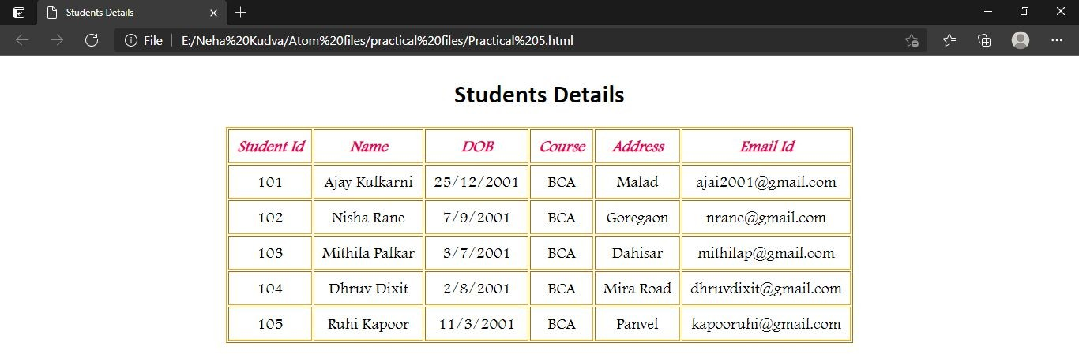

**PRACTICAL - 6**



**AIM: Create an external CSS for above and apply to the web page. CODE:**

**1. table.css**

td

{

text-align: center; font-size: 20px;

font-family: Footlight MT Light, cursive;

}

tr:first-child

{

color: #e6005c; font-weight:bold; font-style: italic;

font-family: comic sans ms, fantasy;

}

table

{

border-color: orange;

}

**OUTPUT:**

**PRACTICAL - 7**

**AIM: Create a frameset that divides browser window into horizontal and vertical framesets.**

**CODE:**

1. **frameset.html**

<!DOCTYPE html>

<html lang="en" dir="ltr">

<head>

<meta charset="utf-8">

<title>FrameSet</title>

</head>

<frameset rows="30%,60%,10%" border="2px" bordercolor="black">

<frame name="top" src="./headerframe.html">

<frameset cols="25%,75%" border="1">

<frame name="left" src="./listframe.html">

<frame name="right">

</frameset>

<frame name="footer" src="./footerframe.html">

</frameset>

<noframes>

<body>Your Browser does not Support Frames</body>

</noframes>

</html>

1. **headerframe.html**

<!DOCTYPE html>

<html lang="en" dir="ltr">

<head>

<meta charset="utf-8">

<title>Header Frame</title>

<style media="screen"> body

{

background-color: #99c2ff;

}

</style>

</head>

<body>

<center>

<img src="./stem cells.jpg" alt="img" height="170px" width="600px">

</center>

</body>

</html>

1. **listframe.html**

<!DOCTYPE html>

<html lang="en" dir="ltr">

<head>

<meta charset="utf-8">

<title></title>

</head>

<body>

<ul>

<li><font face="High Tower Text"><b>More to See</b></font></li><br>

<ol>

<a href="./aboutSC.html" target="right"><li>About Stem Cells</li></a><br>

<a href="./imageSC.html" target="right"><li>Images</li></a>

</ol>

</ul>

</body>

</html>

1. **footerframe.html**

<!DOCTYPE html>

<html lang="en" dir="ltr">

<head>

<meta charset="utf-8">

<title></title>

<style media="screen"> body

{

background-color: #99c2ff;

}

</style>

</head>

<body>

<h1 align="center">© Neha Kudva</h1>

</body>

</html>

**OUTPUT:**

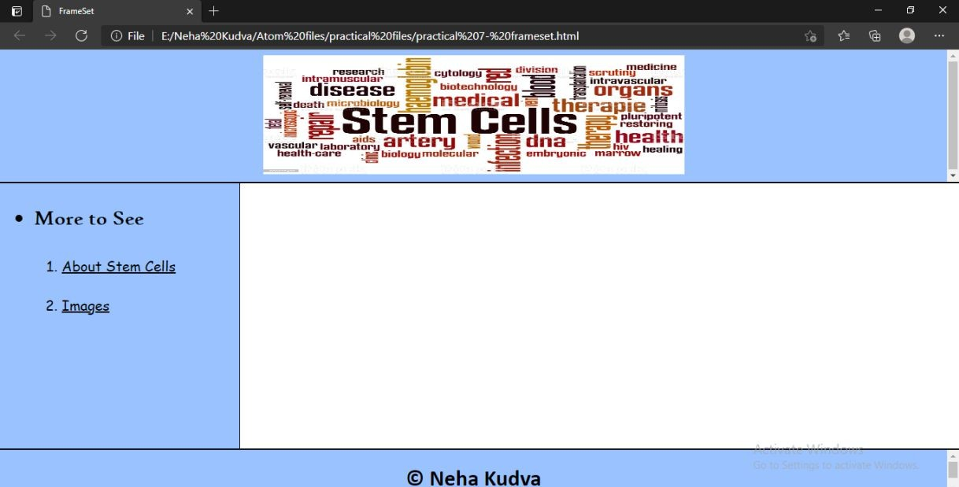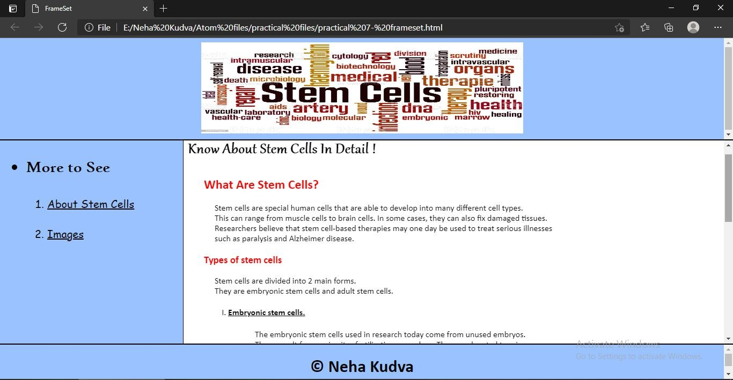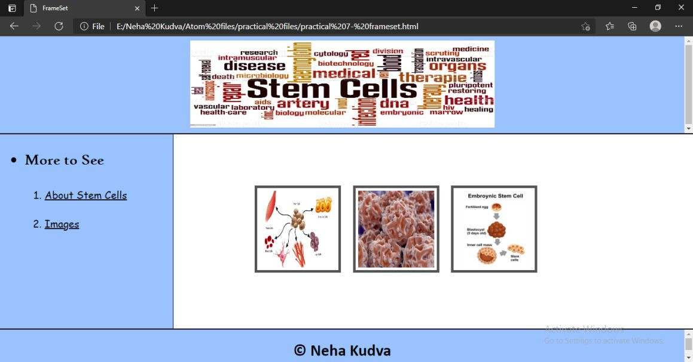

**PRACTICAL - 8**

**AIM: Write the JavaScript code to enter five numbers in the prompt box. Calculate addition of the numbers & average.**

**CODE:**

<!DOCTYPE html>

<html lang="en" dir="ltr">

<head>

<meta charset="utf-8">

<title>Prompt Box</title>

<script type="text/javascript"> function accept()

{

var str = prompt("Enter 5 Numbers") var num= str.split(",");

var n1 = parseInt(num[0]); var n2 = parseInt(num[1]); var n3 = parseInt(num[2]); var n4 = parseInt(num[3]); var n5 = parseInt(num[4]);

var sum = n1+n2+n3+n4+n5; var avg = (sum)/5;

document.write("Sum of the Numbers:",sum); document.write("<br>Average of the Numbers: ",avg);

}

</script>

</head>

<body>

<h1>Mathematical Operations</h1>

<h2>Sum Operations</h2>

<button type="button" onclick="accept()">Input Box</button>

</body>

</html>

**OUTPUT:**

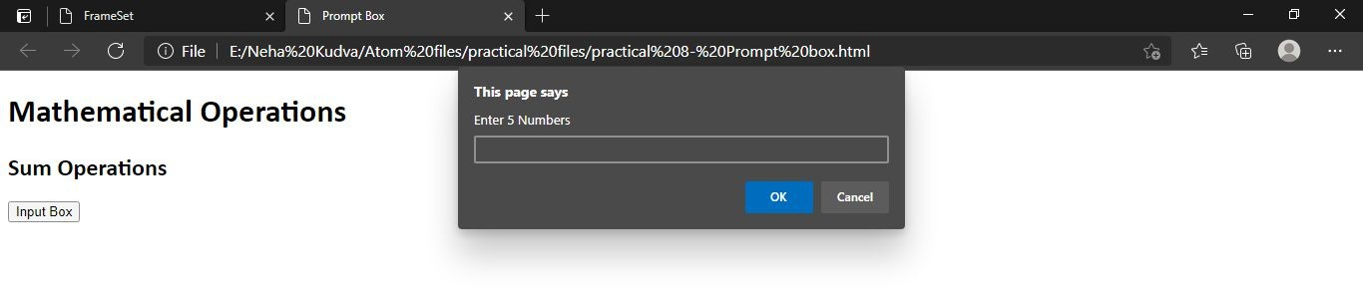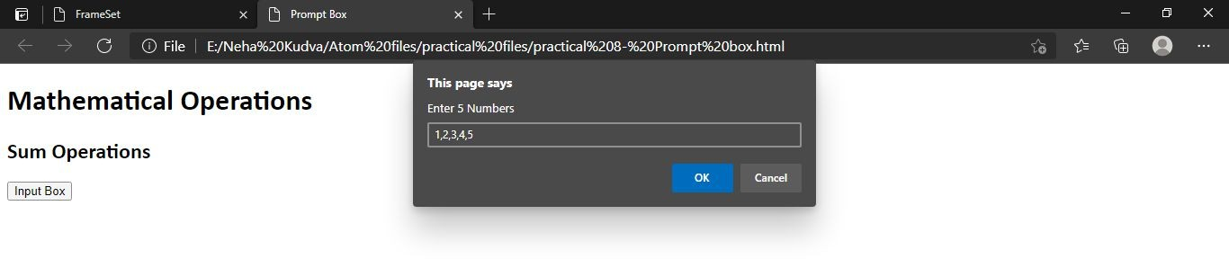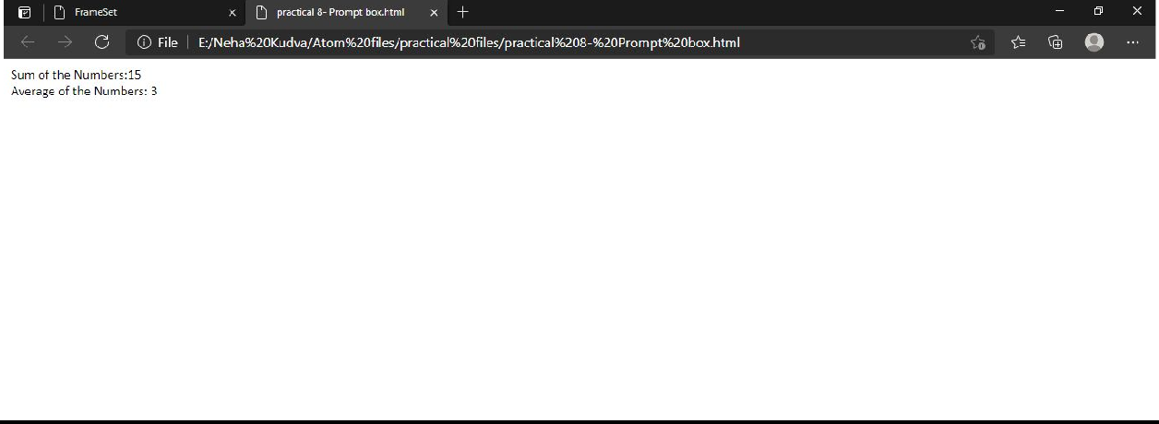

**PRACTICAL - 9**

**AIM: Create a web page with image and text apply JavaScript Mouse events – onmouseover , onmouseout, onclick on the image and text.**

**CODE:**

<!DOCTYPE html>

<html lang="en" dir="ltr">

<head>

<meta charset="utf-8">

<title>Mouse event practical</title>

<script type="text/javascript">

function chngBg(id) { if (id == "img") {

document.body.style.backgroundColor="#802000" ;

} else if (id == "p") { document.body.style.backgroundColor="#F2C649";

}

}

function addBorder(id)

{

if(document.getElementById(id).style.border=="2px solid black")

{

document.getElementById(id).style.border="none"

}

else

{

document.getElementById(id).style.border="2px solid black"

}

}

</script>

<style media="screen"> img

{

display: block; margin-left: auto; margin-right: auto; padding: 20px

}

p

{

display: block; margin-left: auto; margin-right: auto; text-align: center; padding: 10px; width: 20%;

font-size: 30px;

font-family: Gabriola;

}

</style>

</head>

<body>

<img src="./sunset.jpg" id="img" height="400px" width="600px" onmouseover="addBorder('img')" onmouseout="addBorder('img')" onclick="chngBg('img')">

<p id="p" onmouseover="addBorder('p')" onmouseout="addBorder('p')" onclick="chngBg('p')">This Golden Hour Is My Happy Hour</p>

</body>

</html>

**OUTPUT:**

1. **onmouseover() on the image**

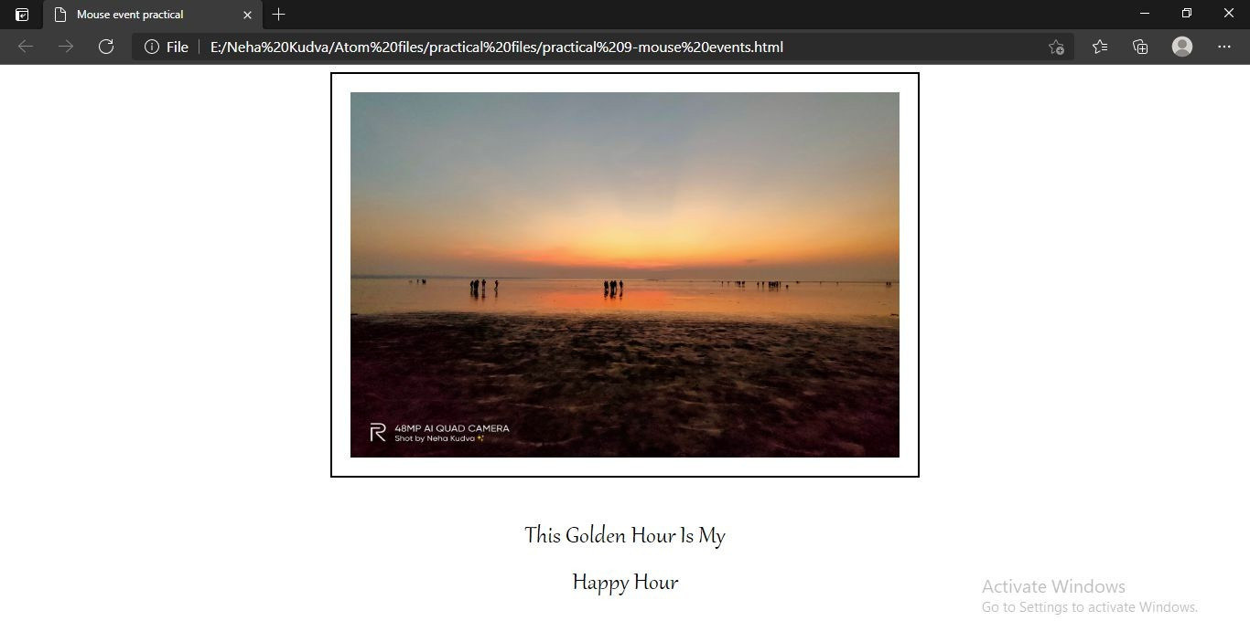

1. **onmouseover() on the text**

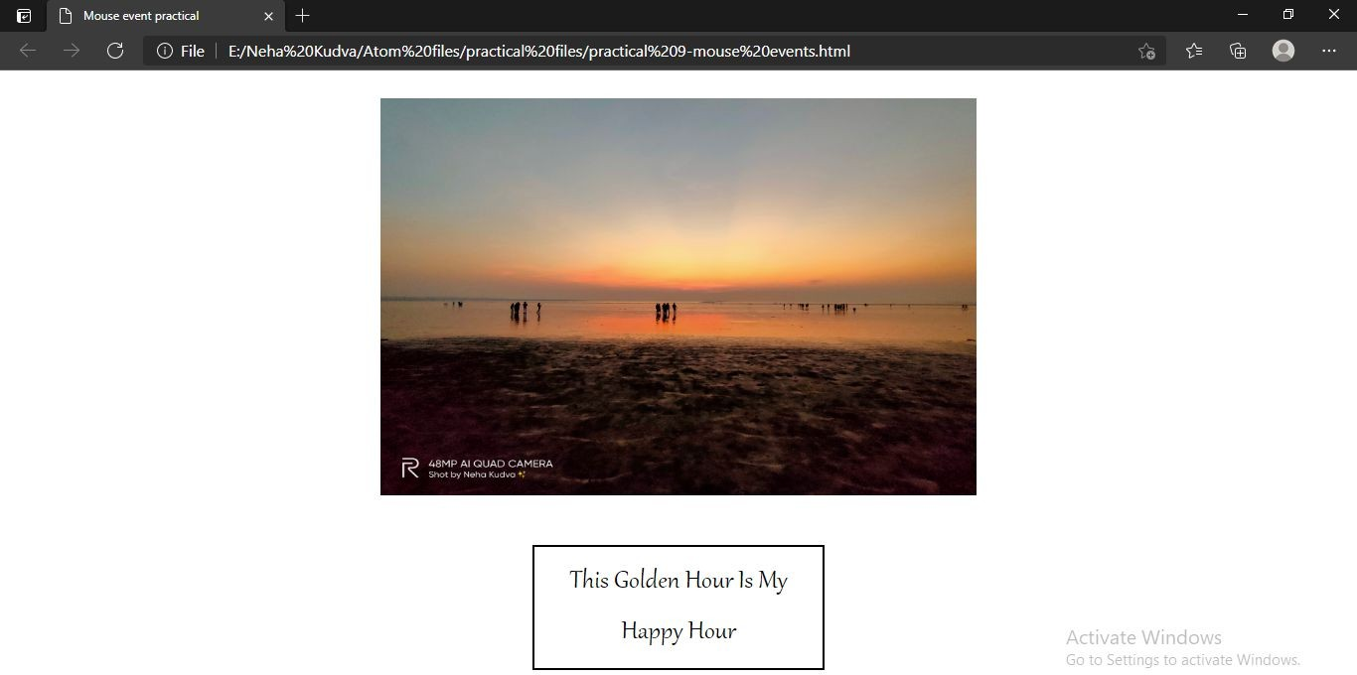

1. **onclick() on the image**

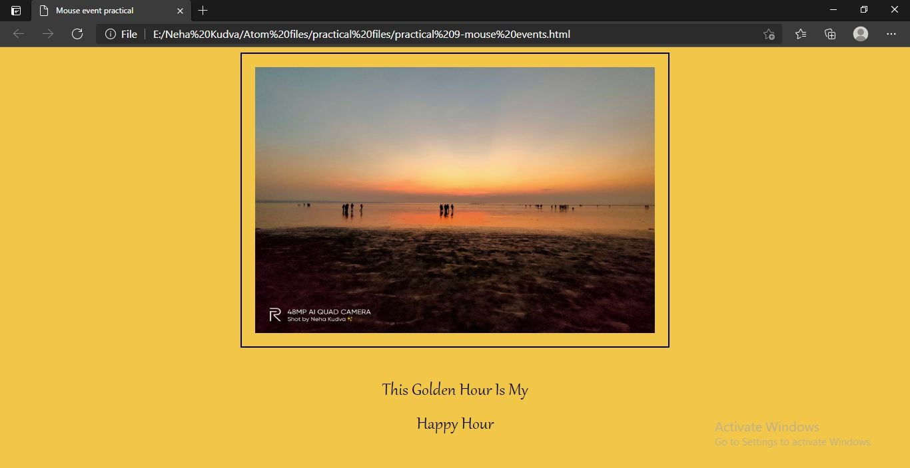

**PRACTICAL - 10**

**AIM: Create a page which displays JavaScript popup boxes :**

* 1. **Alert 2. Confirm 3. Prompt. CODE:**

<!DOCTYPE html>

<html lang="en" dir="ltr">

<head>

<meta charset="utf-8">

<title>PRACTICAL 10</title>

<script type="text/javascript">

function loadDocument()

{

alert("Your document will be loaded soon...");

}

function create()

{

var res = confirm("Are you sure you want to create your Account ?");

if(res == true)

{

var pname = prompt("Please Enter User's Name: "); if(pname != null)

{

document.write("Hello, " +pname+"<br>Your Account Has Been Successfully Created !");

}

}

else

{

document.write("We are sorry to see you go.");

}

}

</script>

</head>

<body onload="loadDocument()">

<hr>

<h2>Create Your Account</h2>

<form class="" action="index.html" method="post">

<table cellspacing="10px">

<tr>

<td>

<label for="name">Enter Name: </label>

</td>

<td>

<input type="text" name="nameid" placeholder="Enter name here" required>

</td>

</tr>

<tr>

<td>

<label for="email">Enter Email ID: </label>

</td>

<td>

<input type="email" name="emailid" placeholder="Enter Email ID here" required>

</td>

</tr>

<tr>

<td>

<label for="uname">Enter Username: </label>

</td>

<td>

<input type="text" name="unameid" placeholder="Enter username here" required>

</td>

</tr>

<tr>

<td>

<label for="pswrd">Enter Password: </label>

</td>

<td>

<input type="password" name="pwid" placeholder="Enter Password here" required>

</td>

</tr>

<tr>

<td>

<label for="cpswd">Enter Confirm Password: </label>

</td>

<td>

<input type="password" name="cpid" placeholder="Confirm your Password" required>

</td>

</tr>

</table>

</form><br>

<button type="button" name="button" onclick="create(this)">Create Account</button>

<br><br>

<hr>

</body>

</html>

**OUTPUT:**

1. **alert box**

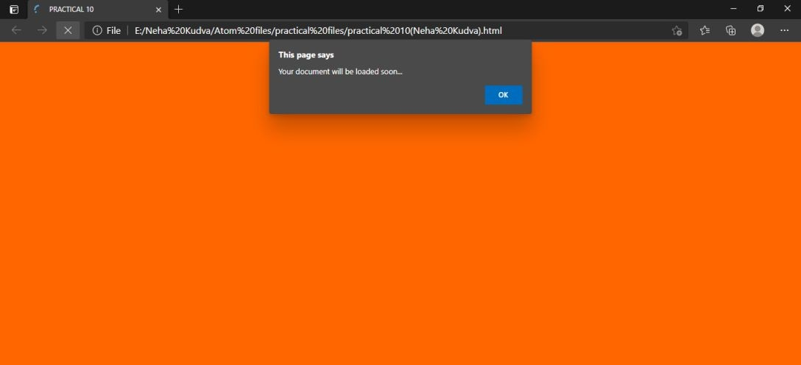

1. **confirm box**

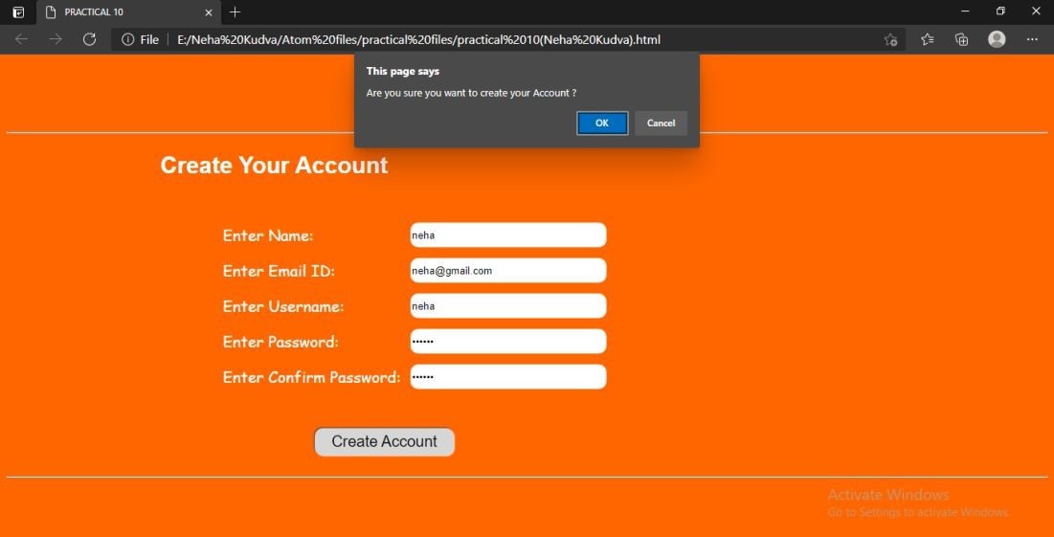

1. **prompt box**

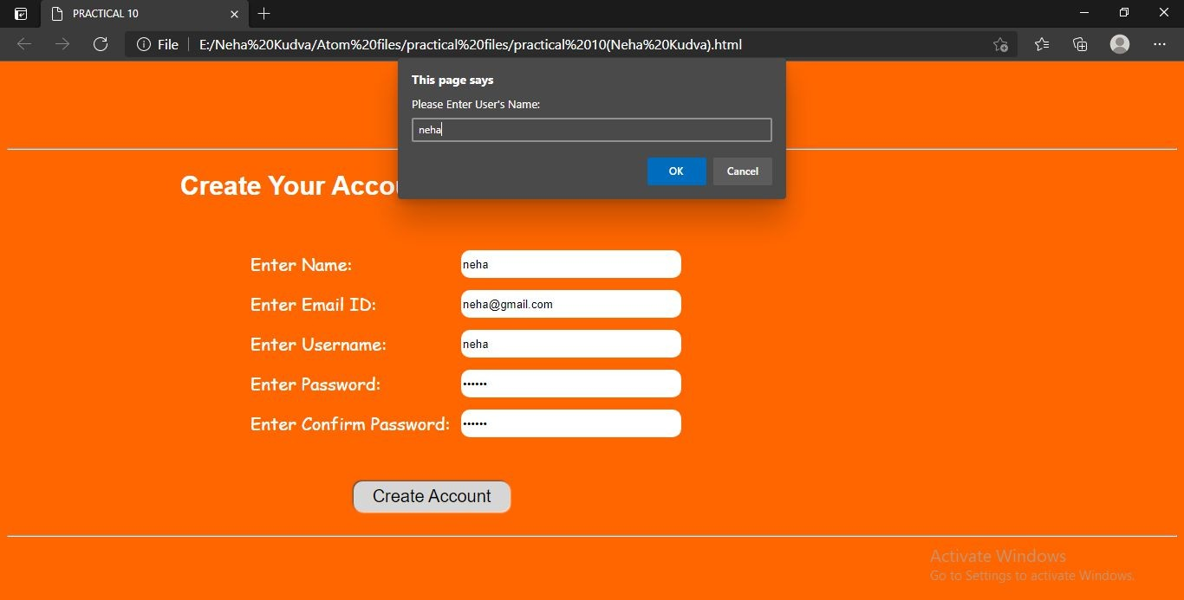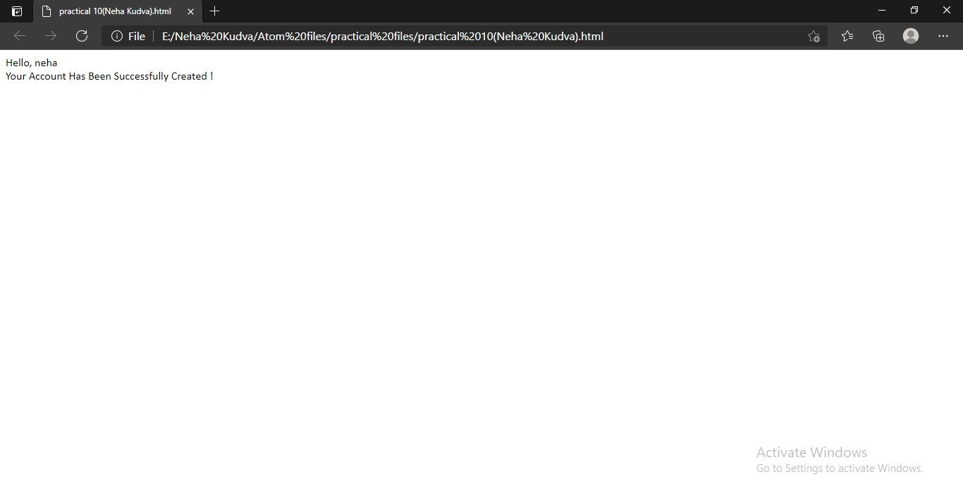

**PRACTICAL - 11**

**AIM: Design a form and validate all the controls placed on the form using Java Script.**

**CODE:**

<!DOCTYPE html>

<html lang="en" dir="ltr">

<head>

<meta charset="utf-8">

<title>Practical 11</title>

<script type="text/javascript">

function validateForm()

{

var txtFirstName = document.getElementById("fname"); var firstname= txtFirstName.value;

var txtPhoneNo = document.getElementById("PhoneNumber"); var phoneNo= txtPhoneNo.value;

var age1 = document.getElementById("age"); var age2= age1.value;

var pass1 = document.getElementById("pwd"); var p1 =pass1.value;

var pass2 = document.getElementById("cpwd"); var p2=pass2.value;

if(firstname == "")

{

alert("Name must be filled out"); txtFirstName.focus();

return false;

}

if(isNaN(phoneNo))

{

alert("Please enter only numberic data"); txtPhoneNo.value= ""; txtPhoneNo.focus();

return false;

}

if (isNaN(age2) || age2 < 15 || age2 > 40)

{

alert("Please enter age from 15 to 40"); age1.value="";

age1.focus(); return false;

}

if(p1.length < 6)

{

alert("**Password should be greater than 6 characters"); pass1.value="";

pass1.focus(); return false;

}

if(p2!=p1)

{

alert("Passwords did not match !"); pass2.value="";

pass2.focus(); return false;

}

return true;

}

</script>

</head>

<body>

<div class="container"><br>

<form class="form" action="circle.html" method="post" onsubmit="return validateForm()">

<h1>Students Registration</h1>

<table cellpadding="5px" cellspacing="5px">

<tr>

<td><label for="name">Students Name: </label></td>

<td><input type="text" name="nameId" id="fname"></td>

</tr>

<tr>

<td><label for="add">Address: </label></td>

<td><input type="text" name="adrId"></td>

</tr>

<tr>

<td><label for="pno">Phone Number: </label></td>

<td><input type="text" name="pnoId" id="PhoneNumber" minlength="10"></td>

</tr>

<tr>

<td><label for="age">Age: </label></td>

<td><input type="text" name="age" id="age"></td>

</tr>

<tr>

<td><label for="mail">Email ID: </label></td>

<td><input type="text" name="email"></td>

</tr>

<tr>

<td><label for="pwd">Password: </label></td>

<td><input type="password" name="pwd" id="pwd"></td>

</tr>

<tr>

<td><label for="cpwd" >Confirm Password: </label></td>

<td><input type="password" name="cpwd" id="cpwd"></td>

</tr>

</table><br>

<button type="submit" name="button">Submit</button><br><br>

</form>

</div>

</body>

</html>

**OUTPUT:**

1. **name validation**

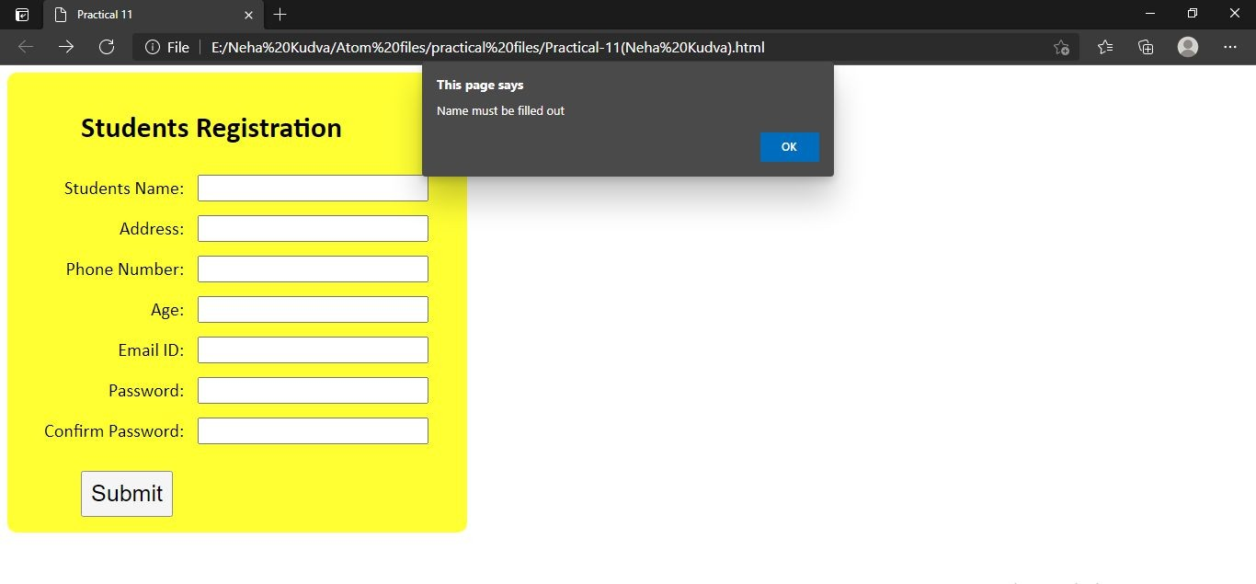

1. **age validation**

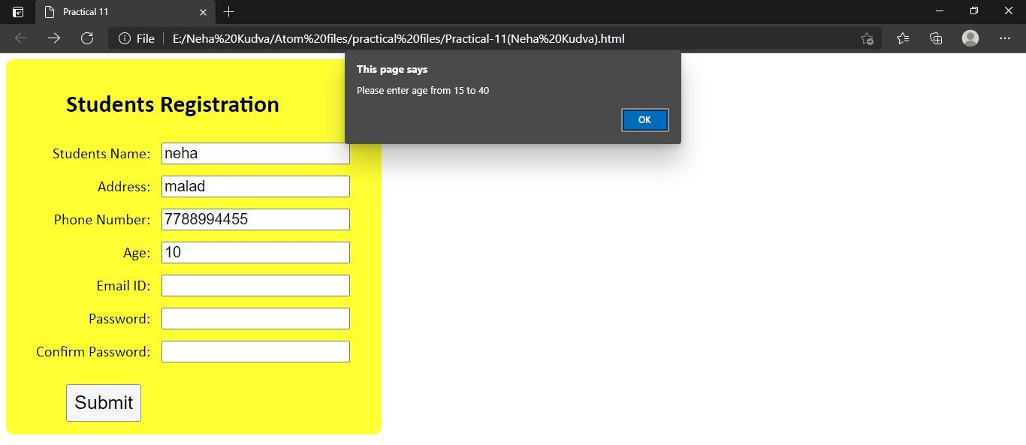

1. **password validation**

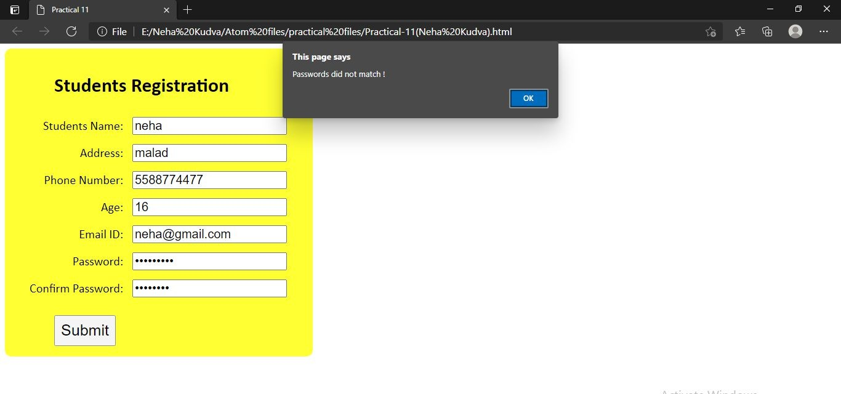

**PRACTICAL - 12**

**AIM: Design a DTD, corresponding XML document and display it in browser using CSS.**

**CODE:**

1. **sports.dtd**

<!DOCTYPE Sports [

<!ELEMENT sports (sport)>

<!ELEMENT sport (name, noOfMembers, type)>

<!ELEMENT name (#PCDATA)>

<!ELEMENT noOfMembers(#PCDATA)>

<!ELEMENT type (#PCDATA)>

] >

1. **sports.xml**

<?xml version="1.0" encoding="UTF-8"?>

<?xml-stylesheet type="text/css" href="sports.css"?>

<!DOCTYPE Sports SYSTEM "sports.dtd">

<sports>

<sport>

<name>CHESS</name>

<noOfMembers>2</noOfMembers>

<type>Indoor</type>

</sport>

<sport>

<name>CRICKET</name>

<noOfMembers>11</noOfMembers>

<type>Outdoor</type>

</sport>

<sport>

<name>BADMINTON</name>

<noOfMembers>2</noOfMembers>

<type>Indoors</type>

</sport>

<sport>

<name>KHO KHO</name>

<noOfMembers>9</noOfMembers>

<type>Outdoor</type>

</sport>

</sports>

**OUTPUT:**

1. **dtd file**

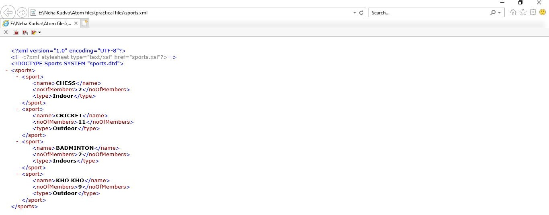

1. **using css**

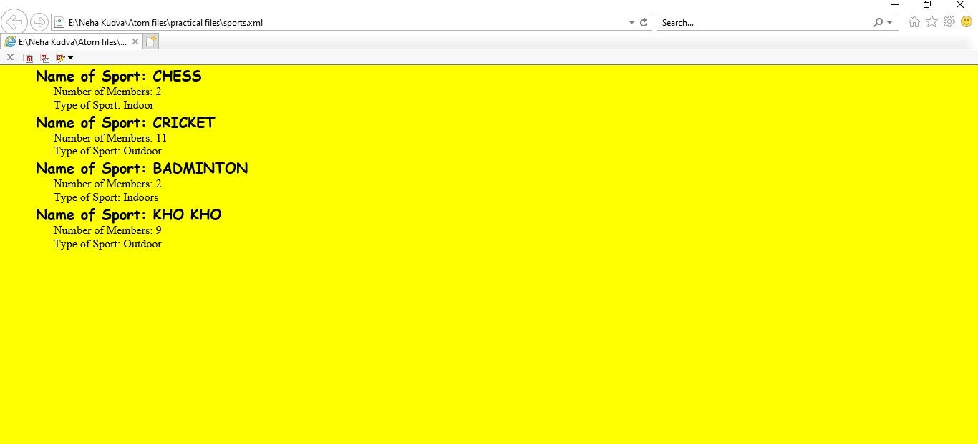

**PRACTICAL - 13**

**AIM: Design an XML document and display it in browser using XSL.**

**CODE:**

1. **sports.xml**

<?xml version="1.0" encoding="UTF-8"?>

<?xml-stylesheet type="text/xsl" href="sports.xsl"?>

<!DOCTYPE Sports SYSTEM "sports.dtd">

<sports>

<sport>

<name>CHESS</name>

<noOfMembers>2</noOfMembers>

<type>Indoor</type>

</sport>

<sport>

<name>CRICKET</name>

<noOfMembers>11</noOfMembers>

<type>Outdoor</type>

</sport>

<sport>

<name>BADMINTON</name>

<noOfMembers>2</noOfMembers>

<type>Indoors</type>

</sport>

<sport>

<name>KHO KHO</name>

<noOfMembers>9</noOfMembers>

<type>Outdoor</type>

</sport>

</sports>

1. **sports.xsl**

<?xml version="1.0" encoding="UTF-8"?>

<xsl:stylesheet version="1.0" xmlns:xsl="<http://www.w3.org/1999/XSL/Transform>">

<xsl:output method="html"/>

<xsl:template match="/">

<html>

<head>

<style> h1

{

text-decoration: underline; font-family: Comic Sans MS; color:#009879;

}

.table

{

top: 50%; left:50%;

border-collapse: collapse; margin: 25px 0;

font-size: 0.9em; min-width: 400px;

font-family: 'Ink Free', sans-serif; border-radius: 5px 5px 0 0;

}

th

{

background-color: #009879; color: #ffffff;

text-align: left; font-weight: bold;

}

th,td

{

padding: 12px 15px;

}

tr

{

border-bottom: 1px solid #dddddd;

}

tr:nth-of-type(odd)

{

background-color: #f3f3f3;

}

tr:last-of-type

{

border-bottom: 2px solid #009897;

}

</style>

</head>

<body>

<center>

<h1>Sports Info</h1>

<table class="table">

<tr>

<th>Name</th>

<th>No. Of Members</th>

<th>Type</th>

</tr>

<xsl:for-each select="sports/sport">

<tr>

<td><xsl:value-of select="name"/></td>

<td align="center"><xsl:value-of select="noOfMembers"/></td>

<td><xsl:value-of select="type"/></td>

</tr>

</xsl:for-each>

</table>

</center>

</body>

</html>

</xsl:template>

</xsl:stylesheet>

**OUTPUT:**

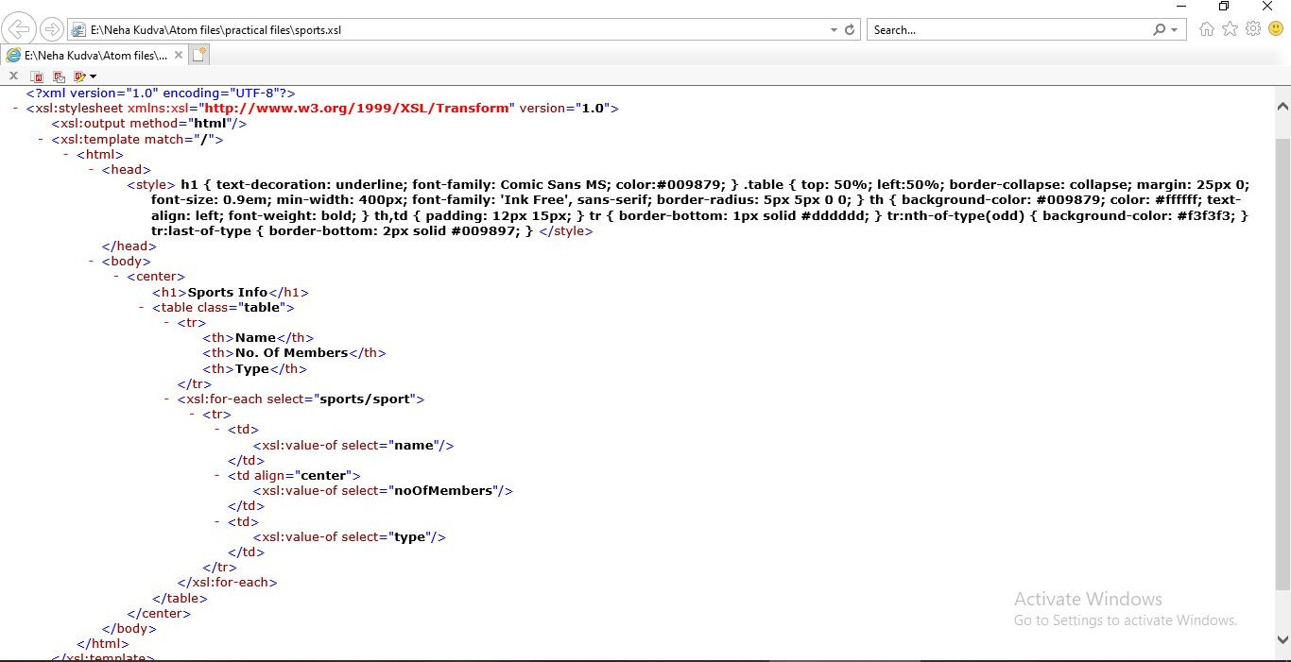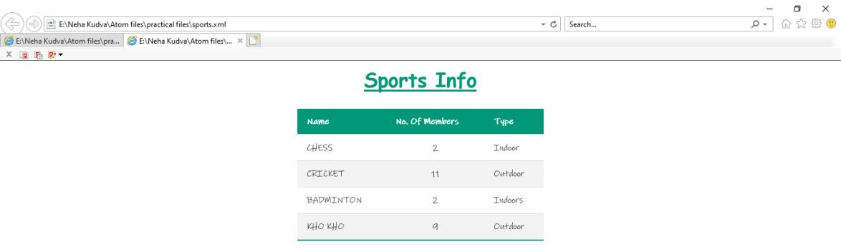

**PRACTICAL - 14**

**AIM: Design XML Schema and corresponding XML document CODE:**

1. **customer.xsd**

<?xml version="1.0" encoding="UTF-8"?>

<xs:schema xmlns:xs = "<http://www.w3.org/2001/XMLSchema>">

<xs:element name="customers">

<xs:complexType>

<xs:element name="customer">

<xs:complexType>

<xs:sequence>

<xs:element name="name">

<xs:complexType>

<xs:sequence>

<xs:element name="firstname" type="xs:string"/>

<xs:element name="lasttname" type="xs:string"/>

</xs:sequence>

</xs:complexType>

</xs:element>

<xs:element name="address">

<xs:complexType>

<xs:sequence>

<xs:element name="city" type="xs:string"/>

<xs:element name="pincode" type="xs:integer"/>

</xs:sequence>

</xs:complexType>

</xs:element>

<xs:element name="phoneNo" type="xs:integer"/>

<xs:element name="email" type="xs:integer"/>

</xs:sequence>

</xs:complexType>

</xs:element>

</xs:complexType>

</xs:schema>

1. **customer.xml**

<?xml version="1.0" encoding="UTF-8"?>

<customers xmlns:xsi="<http://www.w3.org/2001/XMLSchema-instance>" xsi:schemaLocation="Customer.xsd">

<customer>

<name>

<firstname>Rohit</firstname>

<lastname>Khanna</lastname>

</name>

<address>

<city>Mumbai</city>

<pincode>400064</pincode>

</address>

<phoneNo>9988776655</phoneNo>

<email>[rohit@gmail.com](mailto:rohit@gmail.com)</email>

</customer>

<customer>

<name>

<firstname>Tara</firstname>

<lastname>Sharma</lastname>

</name>

<address>

<city>Delhi</city>

<pincode>200044</pincode>

</address>

<phoneNo>9988774433</phoneNo>

<email>[tara@gmail.com](mailto:tara@gmail.com)</email>

</customer>

<customer>

<name>

<firstname>Alia</firstname>

<lastname>Mehta</lastname>

</name>

<address>

<city>Gujarat</city>

<pincode>556</pincode>

</address>

<phoneNo>9988776655</phoneNo>

<email>[amehta@gmail.com](mailto:amehta@gmail.com)</email>

</customer>

<customer>

<name>

<firstname>Mohit</firstname>

<lastname>Shetty</lastname>

</name>

<address>

<city>Chennai</city>

<pincode>9005</pincode>

</address>

<phoneNo>9988776655</phoneNo>

<email>[shetty@gmail.com](mailto:shetty@gmail.com)</email>

</customer>

</customers>

**OUTPUT:**

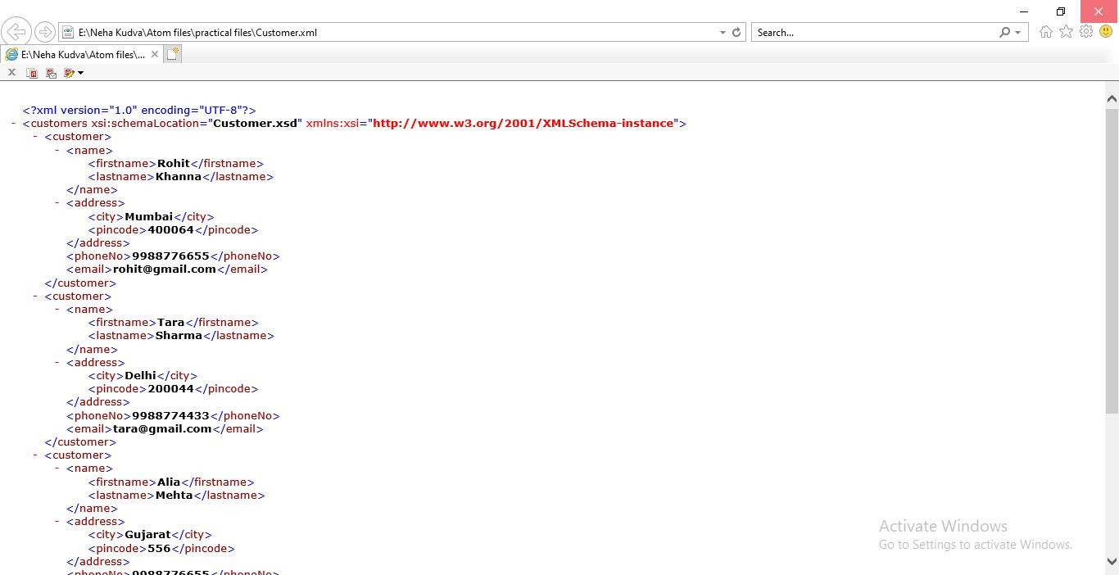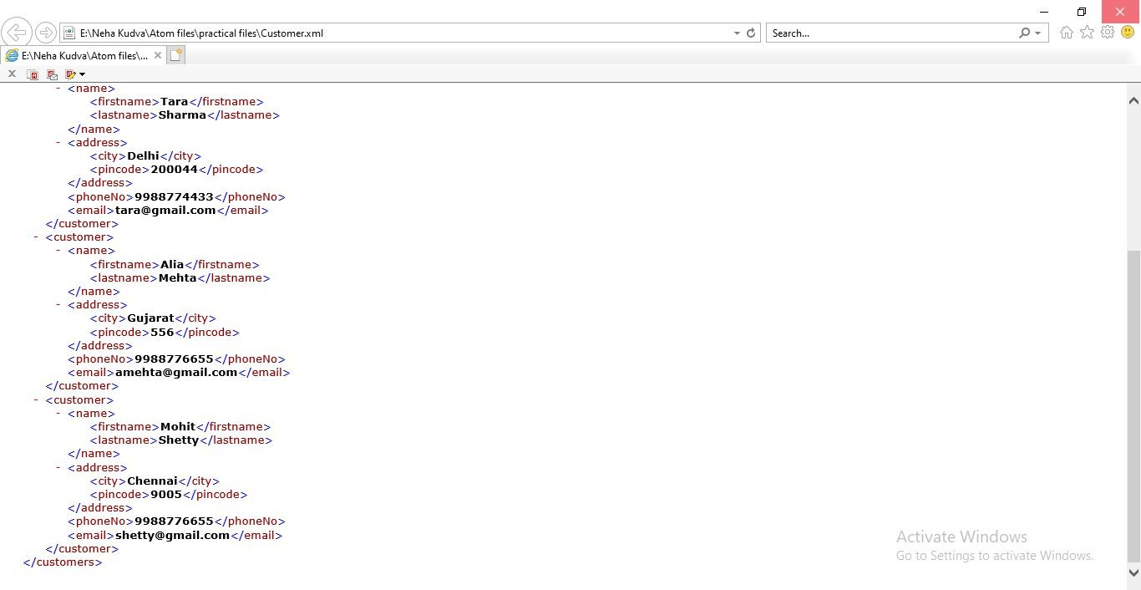

**PRACTICAL - 15**

**AIM: Create a web site with Minimum 3 pages Home, Page 1 and Page2 Incorporate all HTML & DHTML elements. The pages should be linked.**

**CODE:**

1. **Home Page (home.html)**

<!DOCTYPE html>

<html lang="en" dir="ltr">

<head>

<meta charset="utf-8">

<title>home page</title>

<link rel="stylesheet" href="home.css">

</head>

<body>

<div class="container">

<div class="section"><!--First part-->

<div class="bar"><!--bar with titles-->

<div class="bar1">Gaur Gopal Das</div>

<div class="bar2">

<a href="./home.html"><span>Home</span></a>

<a href="./about.html"><span>about</span></a>

<a href="./speaking.html"><span>speaking</span></a>

<a href="./news.html"><span>news</span></a>

<a href="./appointment.html"><span>appointment</span></a>

</div>

<div class="bar3">

<a href="https://[www.facebook.com/gaurgopald"](http://www.facebook.com/gaurgopald) target="_blank"><img src="./fb.png" alt="fb"></a>

<a href="https://[www.instagram.com/gaurgopaldas/](http://www.instagram.com/gaurgopaldas/)" target="_blank"><img src="./ig.jpg" alt="ig"></a>

<a href="https://twitter.com/gaurgopald" target="_blank"><img src="./tt.png" alt="tt"></a>

<a href="https://[www.youtube.com/c/GaurGopalDas](http://www.youtube.com/c/GaurGopalDas)" target="_blank"><img src="./yt.png" alt="yt"></a>

</div>

</div>

<div class="content1"><!--First part-->

<div class="title1">

<h3>inspiring minds. transforming hearts.</h3>

</div>

<div class="title2">

<h4>monk | author | filmmaker | 500 million views </h4>

</div>

<div class="title3">

<a href="./book.html"><button type="button" name="button">read my book</button></a>

</div>

</div>

</div>

<div class="section"><!--second part-->

<div class="content2"><!--second part-->

<div class="pic">

<img src="./g2.jpg" alt="g2">

</div>

<div class="info">

<h2>my journey</h2>

<br>

<p>It's not every day that you visit a monk’s website. I want to thank you for being here! I have been a practicing monk

for twenty-three years, trying to understand the deeper aspects of the human condition: our relationships, our happiness and our purpose.</p>

<p>Today I am a storyteller, life coach, author and a friend to millions that are following my journey on social media. My videos have reached over 500 million views and are all focused on one thing: Making a difference!</p>

<a href="./about.html"><h4>Read More</h4></a>

</div>

</div>

</div>

<div class="section"><!--third part-->

<div class="content3"><!--third part-->

<h2>Keynotes</h2>

<p>I started sharing wisdom with students at some of the most prestigious colleges in Mumbai, but as they all grew up and

began to change their world they wanted me to speak at their companies. I have partnered with institutions like Google, Salesforce, Bombay stock exchange, CII and YPO to name a few.</p>

<div class="slider">

<marquee behavior="scroll" scrollamount="10">

<img src="./google.png" alt="google">

<img src="./salesforce.png" alt="google">

<img src="./TET.png" alt="google">

<img src="./ukp.png" alt="google">

<img src="./ypo.png" alt="google">

<img src="./boa.png" alt="google">

<img src="./bnp.png" alt="google">

<img src="./cii.png" alt="google">

<img src="./ey.png" alt="google">

<img src="./franklin.png" alt="google">

<img src="./franklin.png" alt="google">

</marquee>

</div>

</div>

</div>

<div class="section"><!--fourth part-->

<div class="content4"<!--Fourth part-->>

<h2>nominations</h2>

<p>I think the greatest reward in my life is the opportunity to add value to lives of others. In the course of doing so many have been kind to recognize

some of my endeavors.</p>

</div>

<div class="slider2">

<marquee behavior="scroll" scrollamount="15" behavior="slide">

<img src="./a1.png" alt="award">

<img src="./a2.png" alt="award">

<img src="./a3.png" alt="award">

<img src="./a4.png" alt="award">

<img src="./a5.png" alt="award">

<img src="./a6.png" alt="award">

<img src="./a7.png" alt="award">

<img src="./a8.png" alt="award">

<img src="./a9.png" alt="award">

</marquee>

</div>

</div>

<div class="section"><!--Fifth part-->

<div class="content5"><!--Fifth part-->

<h4>what people say</h4>

<h2>testimonials</h2>

<div class="b1">

<p>“His Teachings can be applied to all people, in all walks of life and at all stages of life.”</p><br>

<p>-Ajay Piramal-</p>

<p>Chairman of the Piramal Group</p>

</div>

<div class="b2">

<p>“Life’s Amazing Secrets is a refreshingly accessible guide which can help man in conquering the daily battle and align him with his purpose in life.”</p><br>

<p>-Devendra Fadnavis-</p>

<p>Ex-Cheif Minister of Maharashtra.</p>

</div>

<div class="b3">

<p>“I am sure this light hearted, conversational book called Life’s Amazing Secrets will help one strike the right balance between work, relationships, society and spirituality.”</p><br>

<p>-Hema Malini-</p>

<p>Bollywood actress, writer and director</p>

</div>

<div class="b4">

<p>“In this increasingly complex world, where placing trust in someone is a hazardous occupation, here comes a refreshingly simple yet effective guide to improving our lives and reducing stress.”</p><br>

<p>-Hrishikesh Mafatlal-</p>

<p>Vice Chairman and chief executive of the Arvind Mafatlal Group of Companies</p>

</div>

<div class="b5">

<p>“Great work. Excellent style. Deep, profound lessons on how to live with purpose and balance, brought out through an entertaining storyline and interesting anecdotes.”</p><br>

<p>-Nitin Gadkari-</p>

<p>Minsiter of Road Transport and Highways in India.</p>

</div>

</div>

</div>

<div class="section"><!--sixth part-->

<div class="content6"><!--sixth part-->

<h4>featured videos from</h4>

<h2>the vlog</h2>

<div class="pictures">

<a href="https://[www.youtube.com/watch?v=I6QwXyE0J9c&t=23s](http://www.youtube.com/watch?v=I6QwXyE0J9c&t=23s)">

<img src="./v1.jpg" alt="v1" style="margin-left: 20px;"></a>

<a href="https://[www.youtube.com/watch?v=rmkQ_wAgwXo"](http://www.youtube.com/watch?v=rmkQ_wAgwXo)><img src="./v2.jpg" alt="v2"></a>

<a href="https://[www.youtube.com/watch?v=rpk6K4EgHWc](http://www.youtube.com/watch?v=rpk6K4EgHWc)"><img src="./v3.jpg" alt="v3"></a>

<div class="text1">

<h5>June 10,2018</h5>

<h3>IF YOU NEED TO SAY SORRY TO SOMEONE- <br> WATCH THIS</h3>

</div>

<div class="text2">

<h5>February 12,2018</h5>

<h3>NEVER JUDGE OTHERS, YOU DON'T KNOW THEIR <br>STORY</h3>

</div>

<div class="text3">

<h5>December 21,2016</h5>

<h3>WHY YOU NEVER HAVE TO WORRY IN LIFE AGAIN</h3>

</div>

</div>

<a href="https://[www.youtube.com/c/GaurGopalDas/playlists](http://www.youtube.com/c/GaurGopalDas/playlists)" target="_blank"><button type="button" name="button">WATCH MORE</button></a>

</div>

</div>

<div class="section"><!--seventh part-->

<div class="content7"><!--seventh part-->

<h1>looking for a keynote speaker?</h1>

<p>Whether you're hosting an event or looking for someone to help your team accelerate their performance, get in touch to learn more.</p>

<br><br>

<a href="./appointment.html" target="blank"><h5>get in touch</h5></a>

</div>

</div>

</div>

</body>

</html>

1. **About Page (about.html)**

<!DOCTYPE html>

<html lang="en" dir="ltr">

<head>

<meta charset="utf-8">

<title>About</title>

<link rel="stylesheet" href="home.css">

<style media="screen"> body

{

background: linear-gradient(rgba(0, 0, 0, 0.7),

rgba(0, 0, 0, 0.7)),

url(g13.jpg); background-repeat: no-repeat; background-size: cover; background-attachment: fixed;

}

h6

{

position: absolute; font-size: 18px;

font-family: 'Calibri',sans-serif; color: #fff;

right: 5%;

top: 2%;

text-decoration: underline;

}

.last a

{

position: absolute; color: #fff;

font-size: 20px; right: 10%;

font-family: 'Arial',cursive;

}

</style>

</head>

<body>

<a href="./home.html"><h6>back to home</h6></a>

<div class="about">

<img src="./g5.jpg" alt="g5" align="right" style="height: 500px;width: 370px;margin: 30px;margin-right: 50px;">

<div class="ab1">

<h2>Who is Gaur Gopal Das?</h2>

<p>Gaur Gopal Das is an Indian spiritual leader, motivational speaker, and lifestyle coach.

Since 1996, he has been serving as a monk and a member of the International Society for Krishna Consciousness (ISKCON). A former electrical engineer, he had worked at Hewlett- Packard (HP) for a while. However, the job did not give him any satisfaction. Thus, he decided to give up his worldly desires and choose the path of spirituality and self-realization. A disciple of Radhanath Swami, Gaur Gopal Das is one of the rarest inspirational speakers from the country to have given lectures in the British parliament and Google’s head office.

Over the years, he has travelled all around the globe to give motivational speeches and lectures on spirituality. A role model and an icon for millions of people, Gaur Gopal Das has inspired many young minds through his quotations, which include ‘Feed your faith and all your doubts shall starve to death’. He has also written several novels and books till date, such as ‘Checkmate,’ ‘Conquest,’ and ‘Revival,’ to name a few.</p>

</div>

<img src="./g12.jpg" alt="g12" align="right" style="height: 230px;width: 370px;margin: 30px;margin-right: 50px;">

<div class="ab2">

<h2>Tenure as a Monk</h2>

<p>In the year 1996, Das became a member of the International Society for Krishna Consciousness (ISKCON). Since then, he has been active in the field of spirituality and is continuously working towards the goal of self-realization under the guidance of his Guru Radhanath Swami.</p>

</div>

<img src="./g11.jpg" alt="g11" align="right" style="position: absolute; height: 400px;width: 300px;margin: 30px;

margin-left: 150px; margin-top:400px;">

<div class="ab3">

<h2>Career as a Motivational Speaker</h2>

<p>As a part of the ISKCON Chowpatty branch, Gaur Gopal Das has been giving lectures at companies and colleges in India and abroad. His seminars are based on topics like happiness, success, and relationships. He once delivered a speech on ‘The Monk Who Bought a Ferrari' at the multinational professional services firm Ernst & Young in London.

He has also spoken at numerous TEDx events and has given lectures at numerous corporates like Barclays, Infosys, Bank of America, Macintosh, Ford, EY, etc.During his 2016 visit to London, Das gave a seminar at the British parliament. In 2017, he was a motivational speaker at the Project Management National Conference held in India. In June that month, he served as a speaker at the Third International Yoga Day conducted by Consulate General of India in Chicago. Das had been a keynote speaker along with Bollywood stars Shatrughan Sinha and Shammi Kapoor at the 'World Kidney Day' event at Ravindra Natya Mandir.

Till date, Das has won several awards from multiple societies and organizations. In 2016, he received the Rotary International's Super Achiever Award for his outstanding contribution in the field of spirituality. He was once awarded the 'Danveer Karna Award' by KIIT University for his selfless contributions to encourage the ideologies of 'Art of Giving'. His show won the title of Best Spiritual/Motivational Show on the Web by IWM Digital Awards 2018.</p>

</div>

<div class="ab4">

<h2>Unknown facts about Guruji</h2>

<p>Gaur Gopal Das is an Electrical Engineer, having studied at the College Of Engineering, Pune.</p>

<p>After a brief stint with Hewlett Packard, he decided to upgrade his career to be a life coach. Consequently in the year 1996 he joined ISKCON & has been very active in this field ever since.</p>

<p>Serving in the leadership at the ISKCON Chowpatty branch, Gaur Gopal Das has been speaking at various prestigious academic institutions in India and abroad for over 2 decades. He has been very actively involved in guiding leading doctors & medical professionals across the globe. Corporate firms like Google, Sales Force, Infosys, Barclays, Bank of America, E&Y, Ford have not been an exception in his areas of continual help & guidance.</p>

<p>Gaur Gopal Das also regularly visits the members of the Rotary Club & Lions Club for talks and guides various top ranking celebrities and corporate leaders. He has also spoken at

several TEDx events. During his 2016 visit to London, he gave a talk at the British Parliament.</p>

<p>He was awarded the 2016 Rotary International's Super Achiever Award for outstanding contribution in field of spirituality and inspiration. He was awarded 'Danveer Karna Award' by KIIT University to recognize his selfless contributions to promote the ideologies of 'Art of Giving' and compassion throughout the world.</p>

<p>He was recently awarded ‘The Ideal Young Spiritual Guru Award’ by the Indian Student Parliament, MIT for his remarkable contributions in offering spiritual guidance to the world at such a young age.</p>

<p>Based on the timeless wisdom coming down from ages, his talks make the audience think deeper and find simple solutions to difficult problems.</p>

<br>

<p>Gaur Gopal Das is a senior monk (brahmachari), a motivational speaker, a life coach at ISKCON (International Society of Krishna Consciousness)</p>

<ol>

<li>His Grace Gaur Gopal prabhu (I will address him respectfully as His grace because I follow his talks a lot and he has inspired me a lot) is originally from Pune.</li>

<li>He is a initiated senior disciple of HH Radhanath Swami Maharaj, who himself is initiated by His Divine Grace AC Bhaktivedanta Swami Prabhupada, who comes from an undisputed lineage, rich in Vedic wisdom, tracing the lineage of gurus, right back to Sri Chaitanya Mahaprabhu, known as a incarnation of Lord Krishna, and the propounder of Gaudiya Vaishnavism sect of bhakti</li>

<li>He is popular on Instagram[1] and YouTube[2]also on Facebook[3] and his motivation videos are viewed by millions of people around the world.</li>

<li>He is a inspiration to many youths like me, and the way he presents Ramayana and Mahabharata through a series of humour, inspiration and motivation, is liked by one and all</li>

</ol>

</div>

<div class="last">

<a href="#top">back to top</a>

<br><br>

</div>

</div>

</body>

</html>

1. **Contact Page(appointment.html)**

<!DOCTYPE html>

<html lang="en" dir="ltr">

<head>

<meta charset="utf-8">

<title></title>

<script type="text/javascript"> function validation()

{

var txtFirstName = document.getElementById("name"); var firstname= txtFirstName.value;

var txtEmail = document.getElementById("email"); var EmailId= txtEmail.value;

var txtAdd = document.getElementById("ad"); var Addss= txtAdd.value;

var txtTopic= document.getElementById("top"); var Topicname= txtTopic.value;

var txtSession = document.getElementById("sesloc"); var sesslocation= txtSession.value;

var txtDOE = document.getElementById("doe"); var dateOfE= txtDOE.value;

var txtNOE = document.getElementById("noe"); var nameOfE= txtNOE.value;

var txtSesad = document.getElementById("sesad"); var SessionAd= txtSesad.value;

var txtPhoneNo = document.getElementById("phone"); var phoneNo= txtPhoneNo.value;

if(firstname == "")

{

alert("Name must be filled out"); txtFirstName.focus();

return false;

}

if(EmailId == "")

{

alert("Email must be filled out"); txtEmail.focus();

return false;

}

if(Addss == "")

{

alert("Address must be filled out"); txtAdd.focus();

return false;

}

if(Topicname == "")

{

alert("Topic is Mandatory"); txtTopic.focus();

return false;

}

if(sesslocation == "")

{

alert("Location must be filled out"); txtSession.focus();

return false;

}

if(dateOfE == "")

{

alert("Date must be filled out"); txtDOE.focus();

return false;

}

if(nameOfE == "")

{

alert("Name must be filled out"); txtNOE.focus();

return false;

}

if(SessionAd == "")

{

alert("Session Address is mandatory."); txtSesad.focus();

return false;

}

if(isNaN(phoneNo))

{

alert("Please enter only numberic data"); txtPhoneNo.value= ""; txtPhoneNo.focus();

return false;

}

if(phoneNo.length < 10 || phoneNo.length > 10)

{

alert("**Incorrect digits in Phone Number"); txtPhoneNo.value="";

txtPhoneNo.focus(); return false;

}

var res = confirm("Do you want to Confirm your booking"); if(res == true)

{

var pname = prompt("Please Enter User's Name: "); if(pname != null)

{

document.write("Hello, " +pname+"<br>Your Session Has Been Successfully booked !<br>Our Team Will Get In Touch With You Soon.");

}

}

else

{

document.write("We are sorry to see you go.");

}

}

</script>

</head>

<body>

<a href="./home.html"><h6>back to home</h6></a>

<br><br>

<div class="banner">

<img src="./g8.jpg" alt="g8">

<hr>

<h2>Book your Dates</h2>

<hr>

<br>

<p>To inquire about booking Gaur Gopal Das for a speaking engagement or for any general questions, feel free to fill out the form below. For a faster response, get in touch with our team at +918268050000</p>

</div>

<div class="appoint">

<div class="fill">

<form method="post" onsubmit="return validation()">

<h5>Please Fill All The Required Fields.(*)</h5>

<a id="top"></a>

<table cellspacing="5" cellpadding="5">

<tr>

<td>Name<span>*</span>

<input type="text" name="nameID" id="name"> </td>

</tr>

<tr>

<td>Phone No<span>*</span> <input type="text" name="phoneID" id="phone">

</td>

</tr>

<tr>

</td>

<td>Email Id<span>*</span> <input type="email" name="emailID" id="email">

</tr>

<tr>

<td>Address<span>*</span> <input type="text" name="address" id="ad"></td>

</tr>

<tr>

<td><hr></td>

</tr>

<tr>

<td>Topic<span>*</span> <input type="text" name="topic" id="top"> </td>

</tr>

<tr>

<td>Session Location<span>*</span> <input type="text" name="location"

id="sesloc"> </td>

</tr>

<tr>

<td>Date Of Event<span>*</span> <input type="date" name="date" id="doe">

</td>

</td>

</tr>

<tr>

<td>Name Of Event<span>*</span> <input type="text" name="ename" id="noe">

</tr>

<tr>

<td>Session Address<span>*</span> <input type="text" name="add2"

id="sesad"> </td>

</tr>

<tr>

<td><hr></td>

</tr>

<tr>

<td>Expected Number Of Attendees: <input type="number" name="count"> </td>

</tr>

<tr>

<td>Whats Your Speaker Budget: <input type="text" name="budget"> </td>

</tr>

<tr>

<td>Any Exceptions Or Anything I Should Avoid While Speaking <textarea name="msg1" rows="6" cols="80"></textarea></td>

</tr>

<tr>

<td>Message: <br><textarea name="msg2" rows="6" cols="80"></textarea> </td>

</tr>

<tr>

<td>Any Other Details:<br><textarea name="msg3" rows="6" cols="80"></textarea> </td>

</tr>

</table>

<button type="submit" name="button">Confirm Booking</button>

</form>

</div>

</div>

<div class="last">

<a href="#top">back to top</a>

<br><br>

</div>

</body>

</html>

**OUTPUT:**

# Home Page:

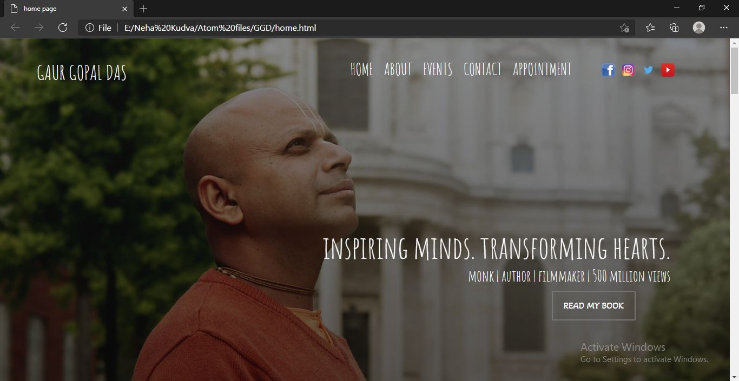

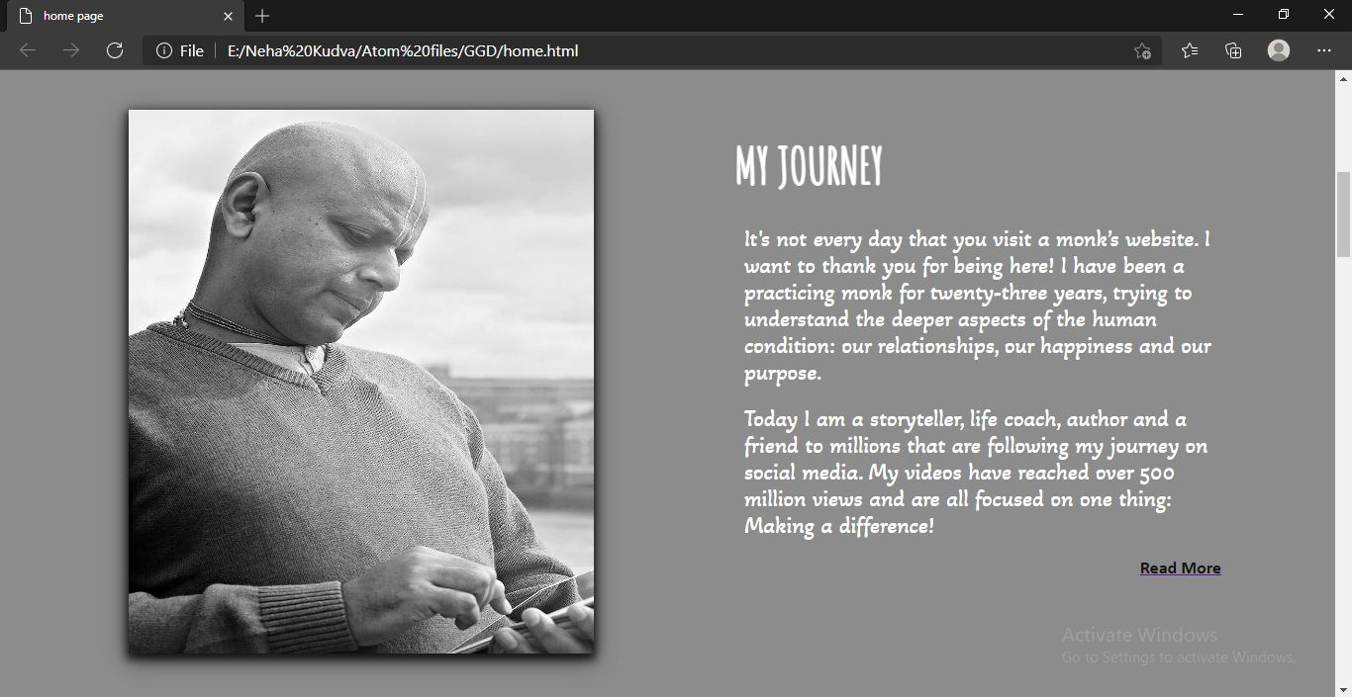

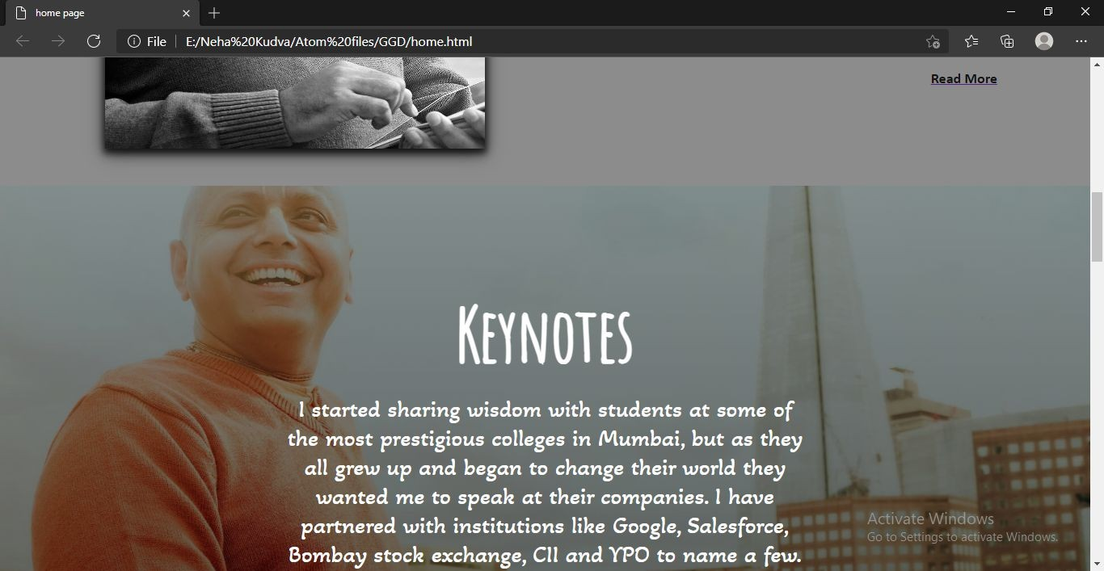

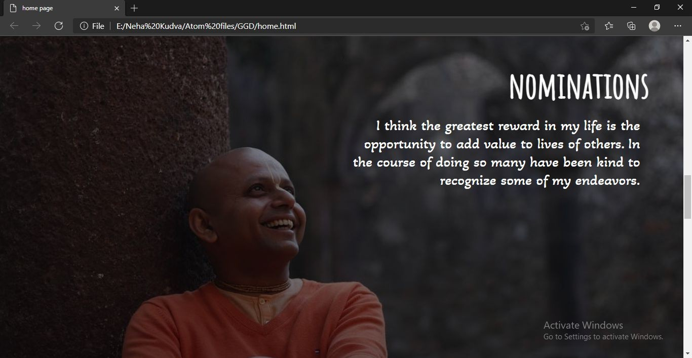

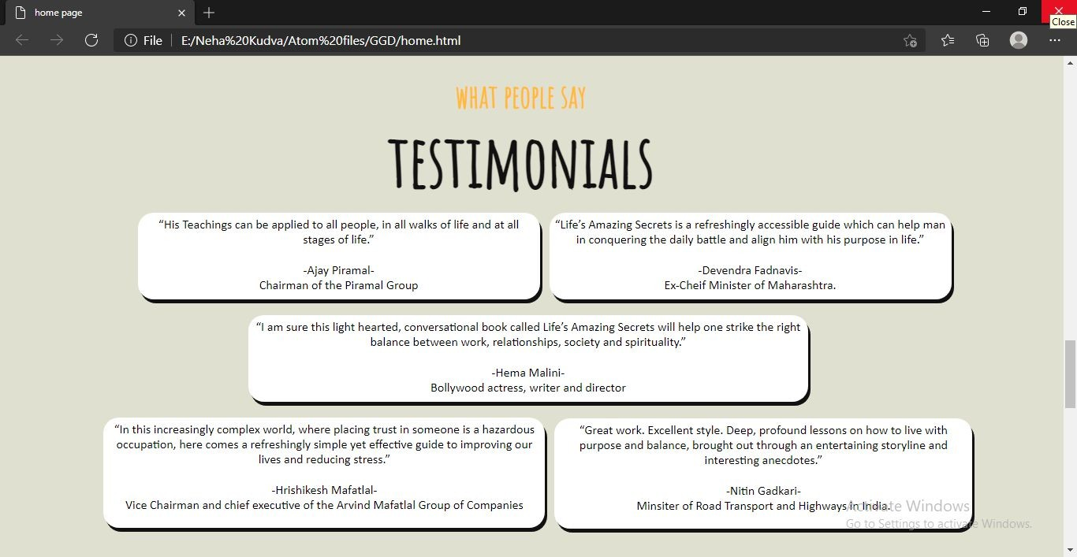

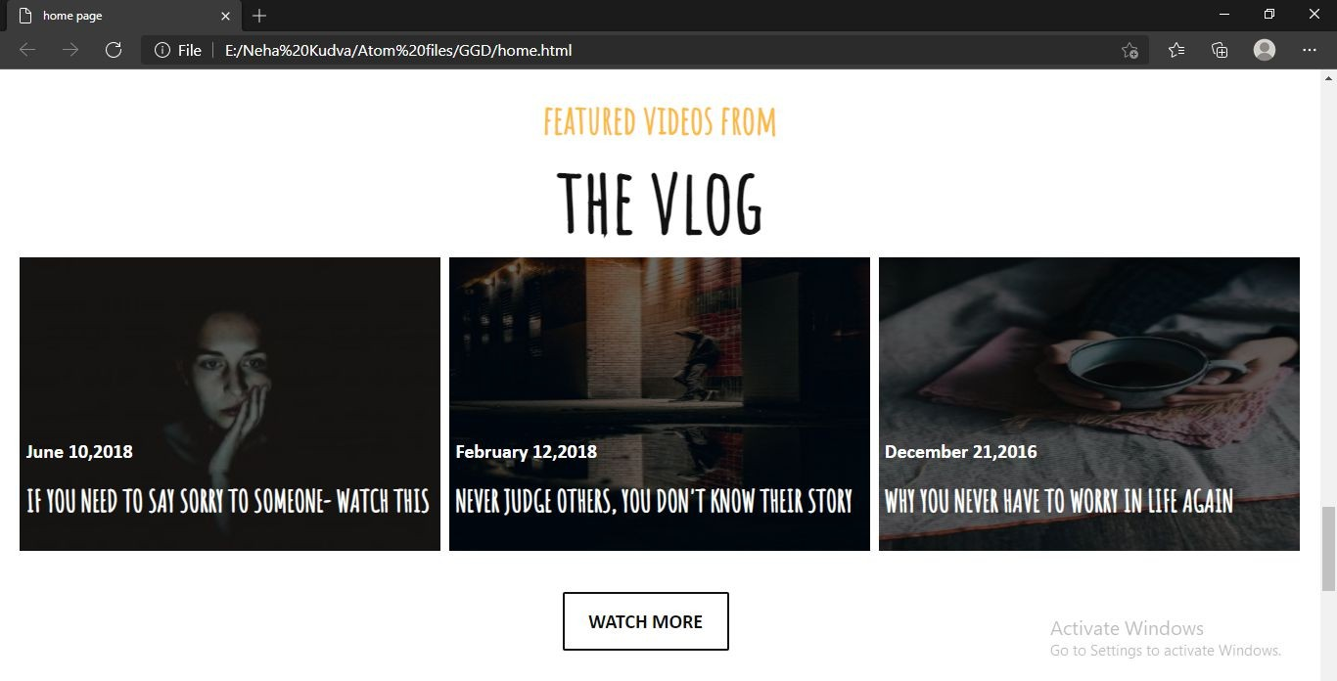

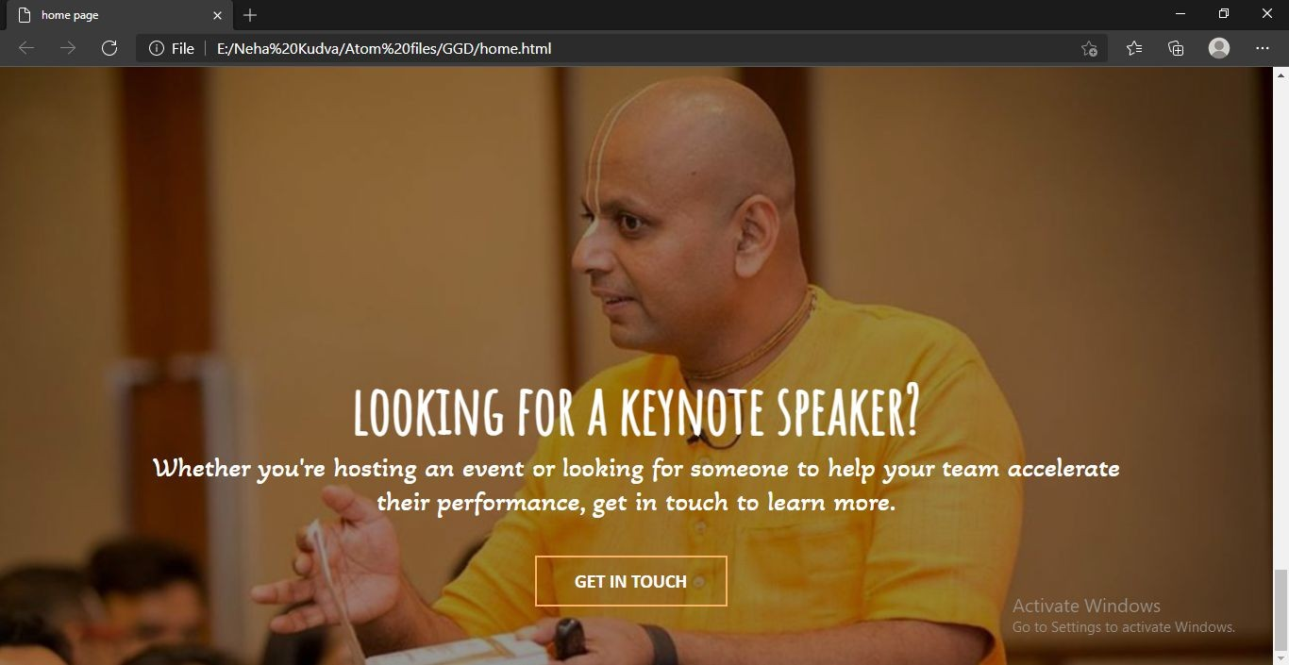

**About Page:**

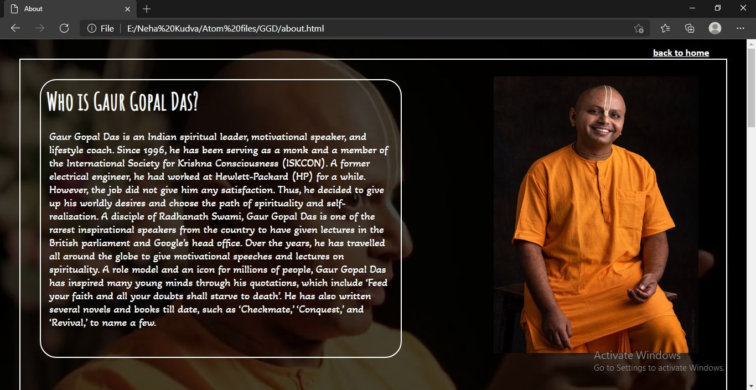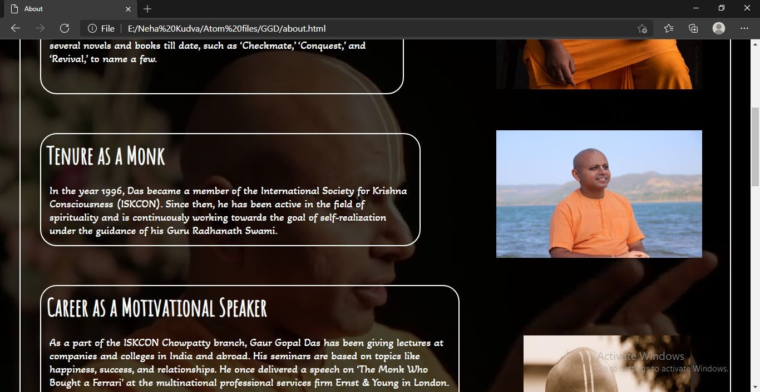

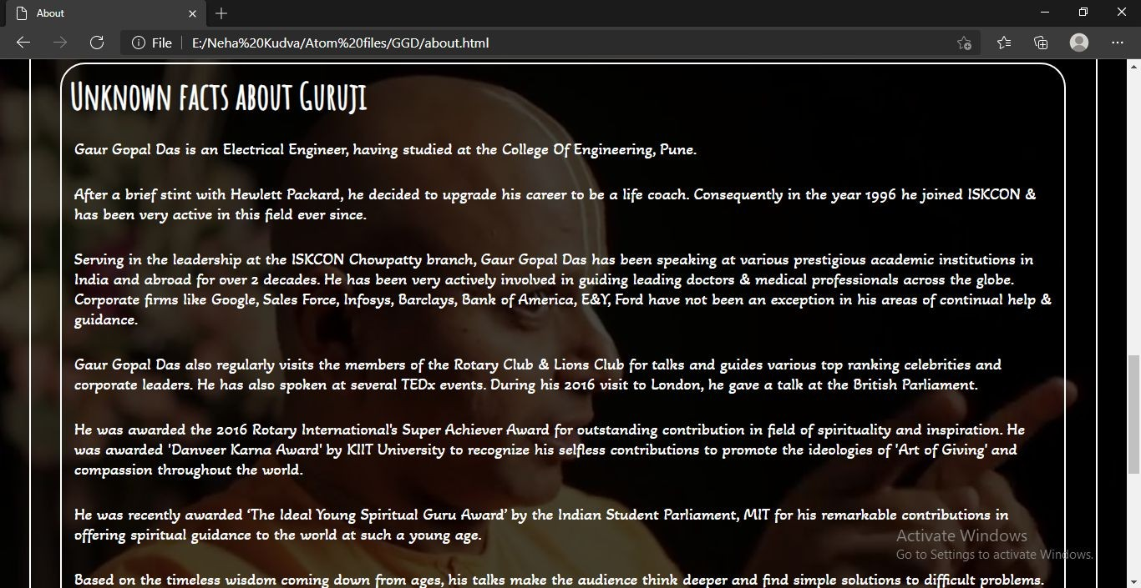

# About His Book:

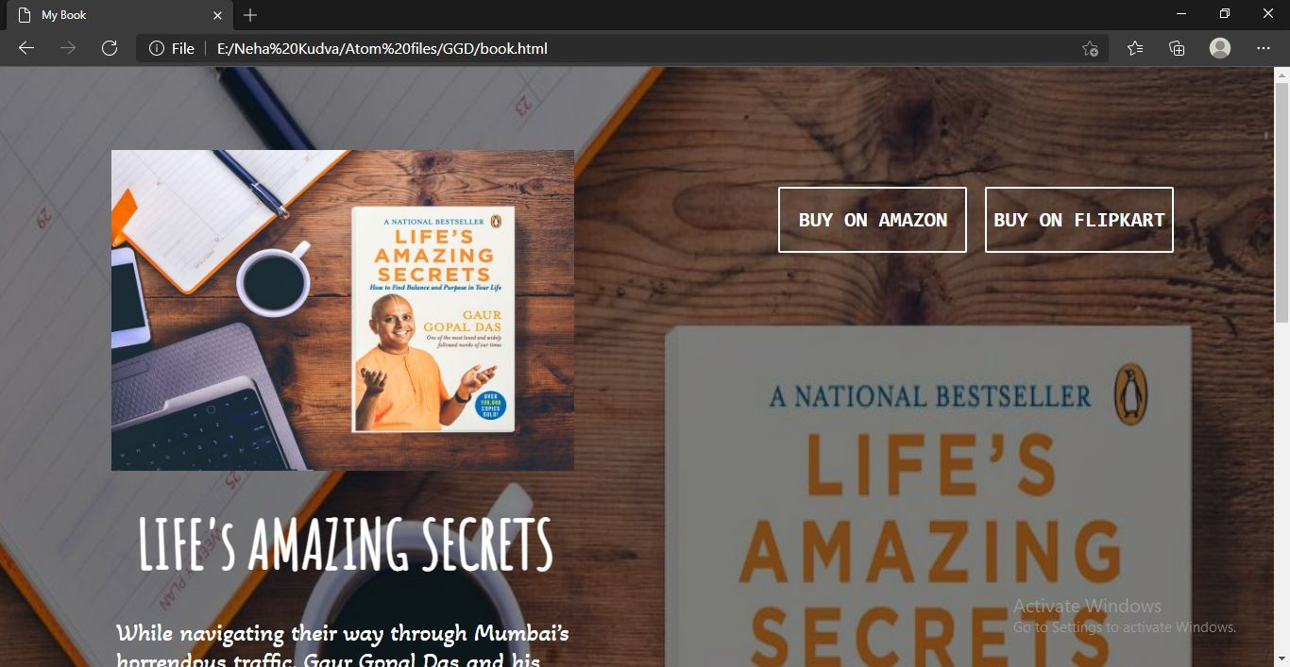

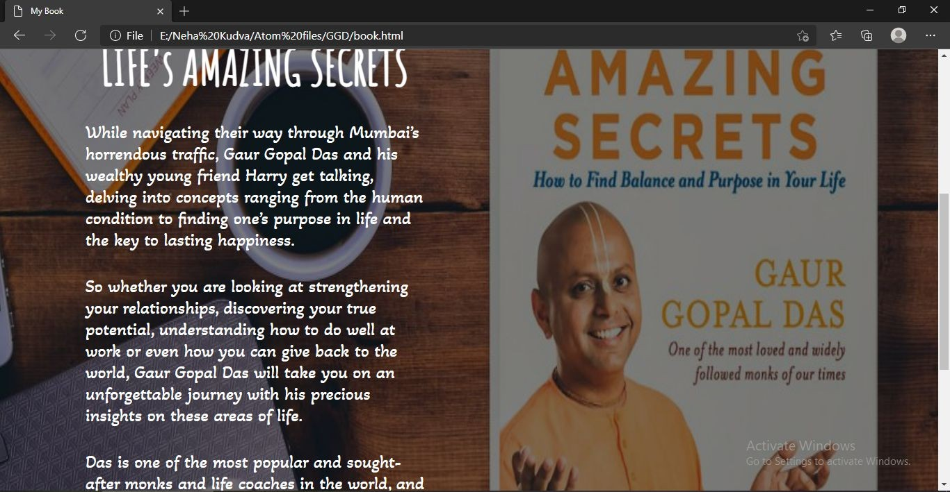

**Appointment Form:**

